**MKS MFC Web Browser Tutorial**

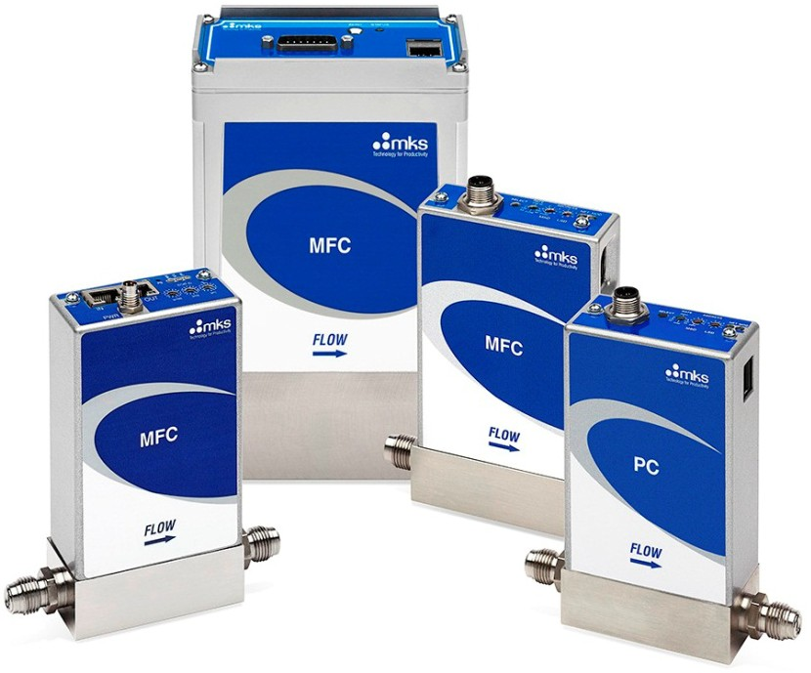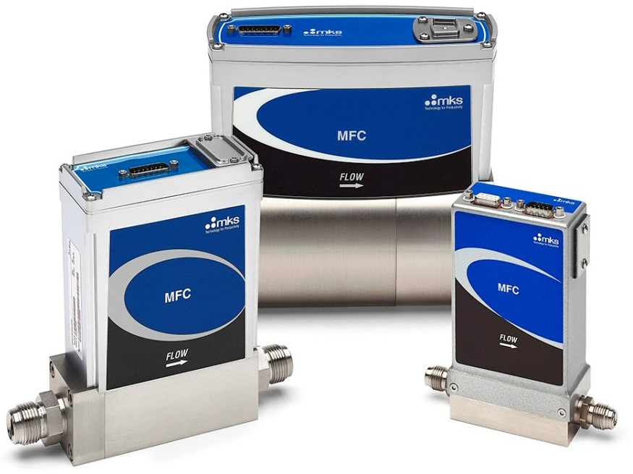

# Section 1: Establishing Ethernet Communication from Computer to MFC

## Changing Local Area Connection Properties for Windows 7 OS:

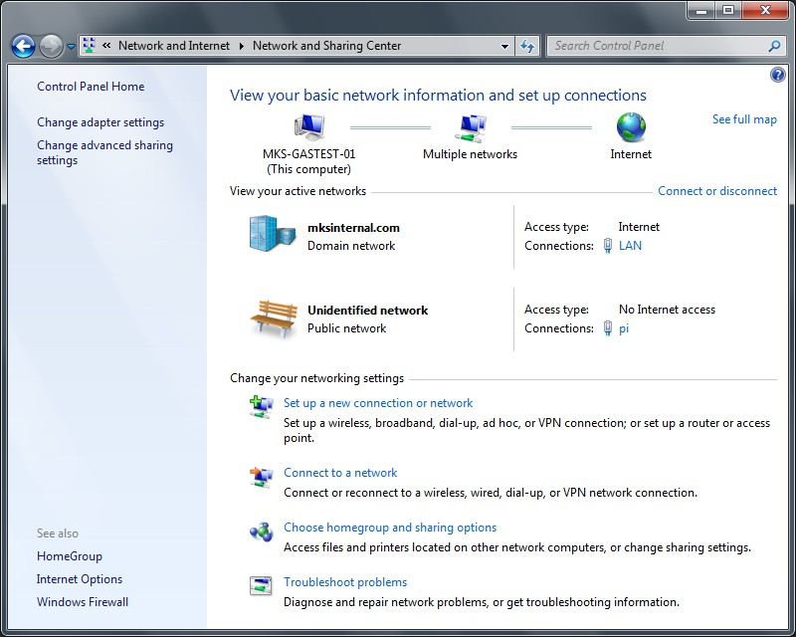

* Open the <Control Panel> on the startup menu. Select <Network and Internet> and view the active networks on the laptop
* Double click on the local area connection to open.

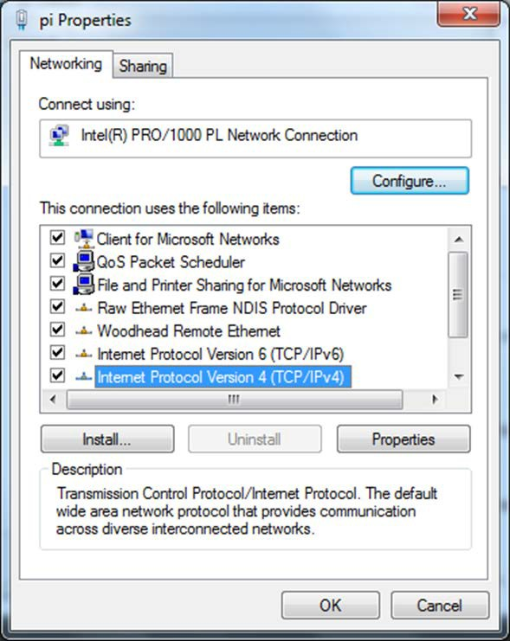

* Left click to highlight <Internet Protocol Version 4 (TCP/IPv4)>.
* Select <Properties>.

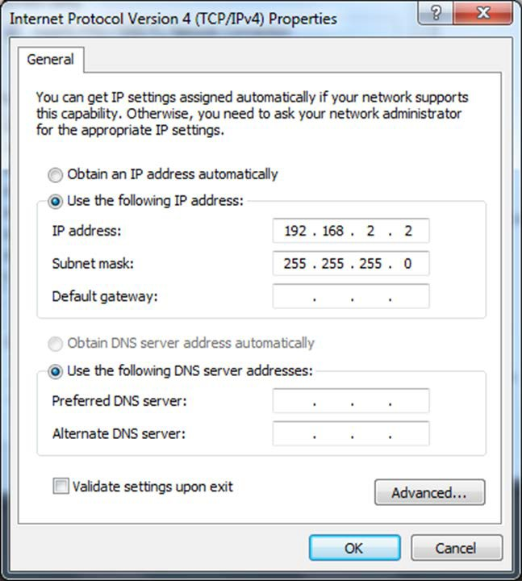

* A new pop up will appear related to “Internet Protocol Version 4 (TCP/IPv4) Properties” which allows you to change the default IP address of the communication port.
* Select “Use the following IP Address”.
* Enter a unique IP address. In this case a unique address 192.168.2.2 was entered into the IP Address line.
* Hit the <Tab> key on the left hand side of the keyboard and a Subnet mask is entered as 255.255.255.0.
* Click OK to select and close the window.
* Once the address has been updated close the remaining network connection windows.
* The laptop is ready for Ethernet communication with MKS MFC devices.

## Changing Local Area Connection Properties for XP OS:

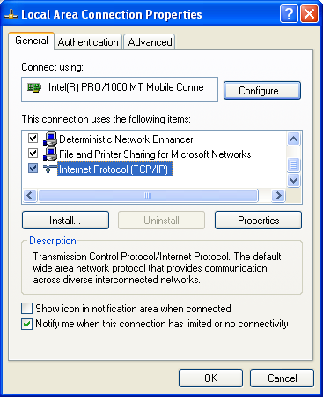

* On the laptop, open network connections page for the Ethernet local area connection.
* Right click on the local connection (in this case 2) and select Properties.
* The small pop up appears, scroll down to “Internet Protocol TCP/IP” and highlight (select).
* Move cursor to “Properties” and left click to select.

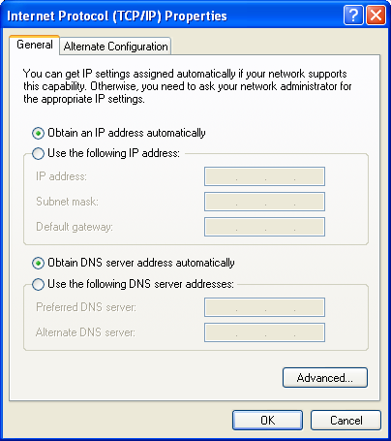

* A new pop up will appear related to “Internet Protocol (TP/IP) Properties”. This allows changes to the default IP address of the communication port.
* Select “Utilize the following IP Address”.
* As shown in the next slide a unique IP address must be assigned to this local area communication port.

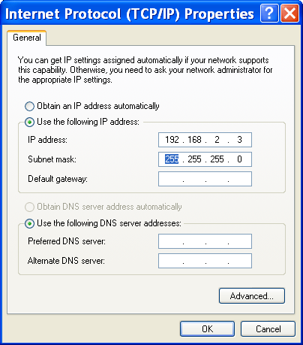

* In this case selected a unique address 192.168.2.3 was entered into the field.
* Hit the tab key on the left hand side of the keyboard and a Subnet mask is entered as 255.255.255.0.
* Click OK to select and close the window.
* Once the address has been updated close the remaining network connection windows.
* The laptop is ready for Ethernet communication with MKS MFC Devices.

# Section 2: Opening the Web Browser in Monitor Mode

## Device Page – Monitor Mode:

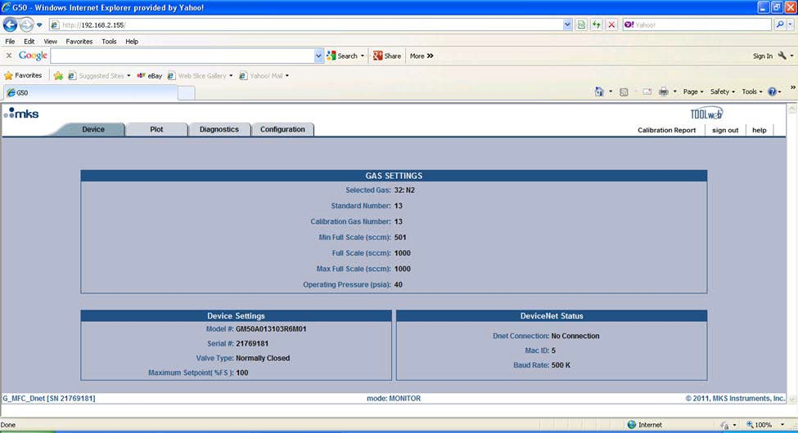

* The front page of the browser opens up in the monitor mode and displays the current setup of the device:
  1. Gas Setting - Selected Gas, Min and Max full scale
  2. Device Settings – Model Code and Serial Number

## Plot Page – Monitor Mode:

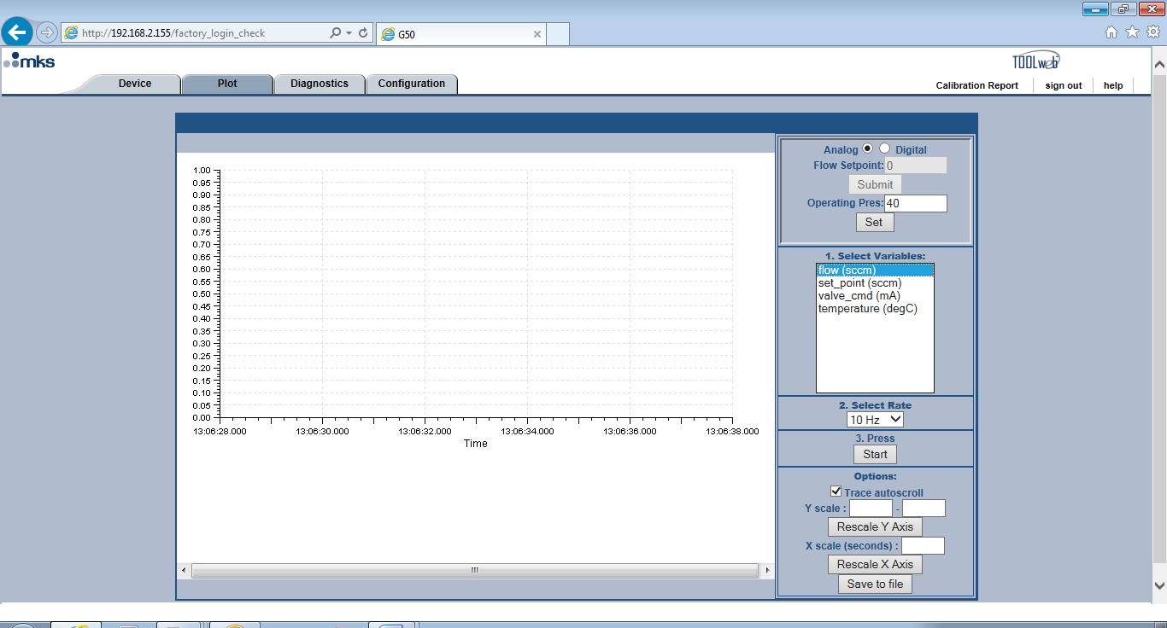

* Plot page is functional in the Monitor Mode.

## Configuration Page – Monitor Mode:

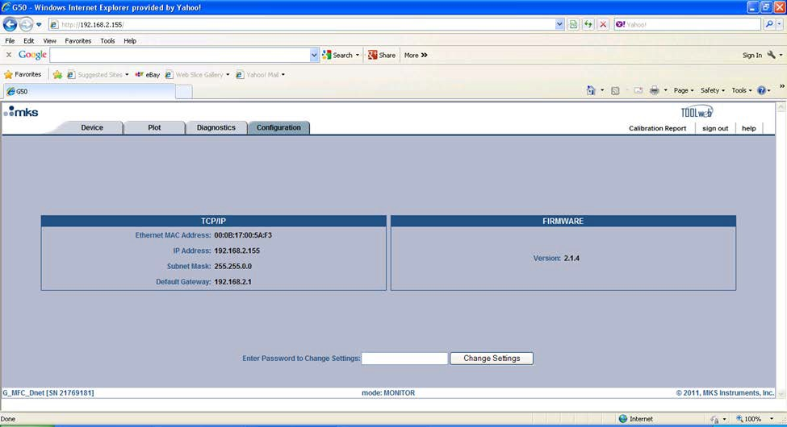

* The configuration page provides information about the current firmware revision.
* At the bottom of the page is a box that provides additional open access to the Web Browser by entering the password “config” and hitting the <Change Settings> button.

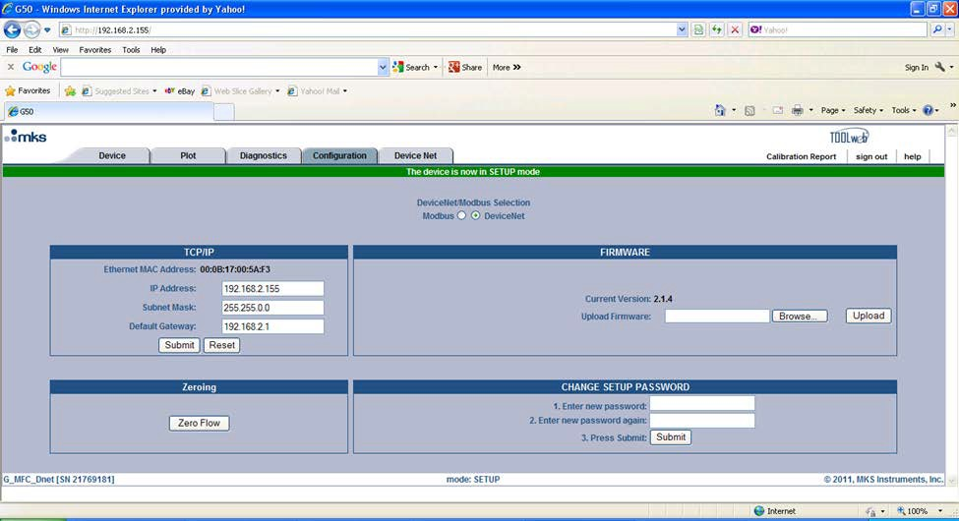

* Once the Browser has been updated the MFC will have been converted to the “Setup Mode”.

# Section 3: Web Browser Setup Mode

* The Setup Mode allows for the User to be able to access and make changes to a variety of Device features on each of the Tabs located at the top of the page.

## Setup Mode: Device Tab

### Gas Settings Section:

* Information in this section of the <Configuration> page describes what gas, and gas instance, is currently selected on the MFC. The full scale of the device is also shown for the current setup.

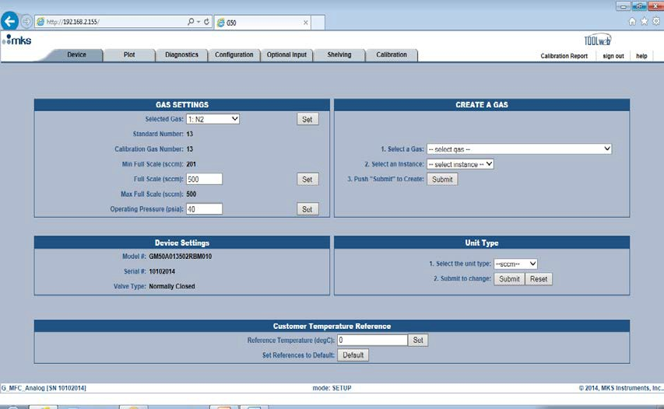

* The MFC is shipped to the customer with 2 gas tables loaded on the Device (unless a special is ordered by the customer that requests a different set up).

***Instance 32*** is the manufacturing N2 calibration table.

***Instance 1*** is the nameplate gas ordered by the customer

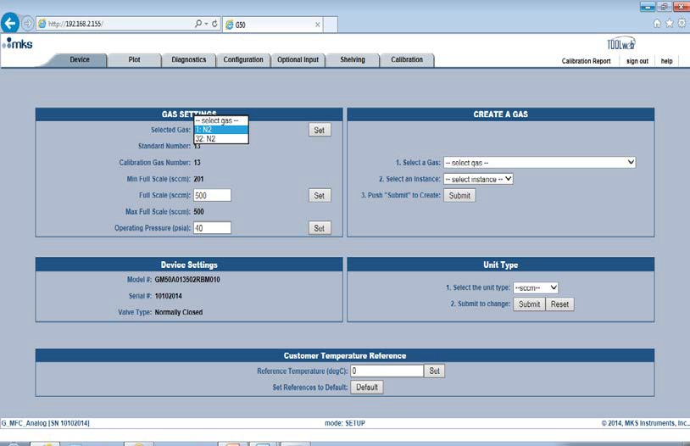

* The last step in the configuration process during manufacturing is to setup Instance 1 to the correct Gas type and Full scale per the device model code. The device ships to the customer configured in Instance 1.

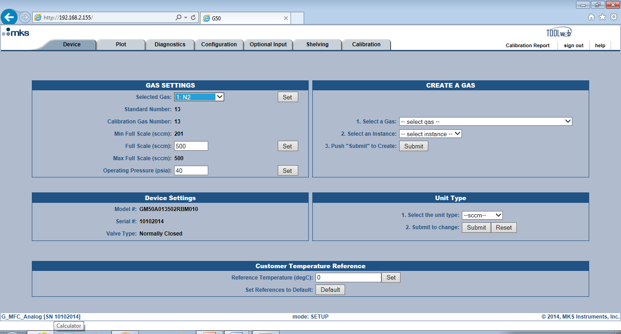

* Device Full Scale is defined by the model code, but the MFC can be re-ranged to any value between the Min FS and the FS of the device.

To change the FS value, enter the target full scale value into the FS box and hit <Set>.

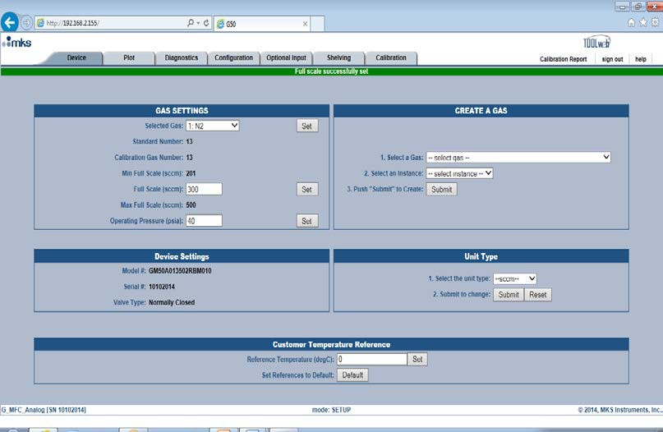

### Create a Gas:

* The ability to create a new gas table (and set the Full Scale range) allows the user the flexibility to utilize one MFC mechanical configuration for different gas, and, gas mixtures.
* The selection process begins by using the pull down menu to find and left click on a gas choice.

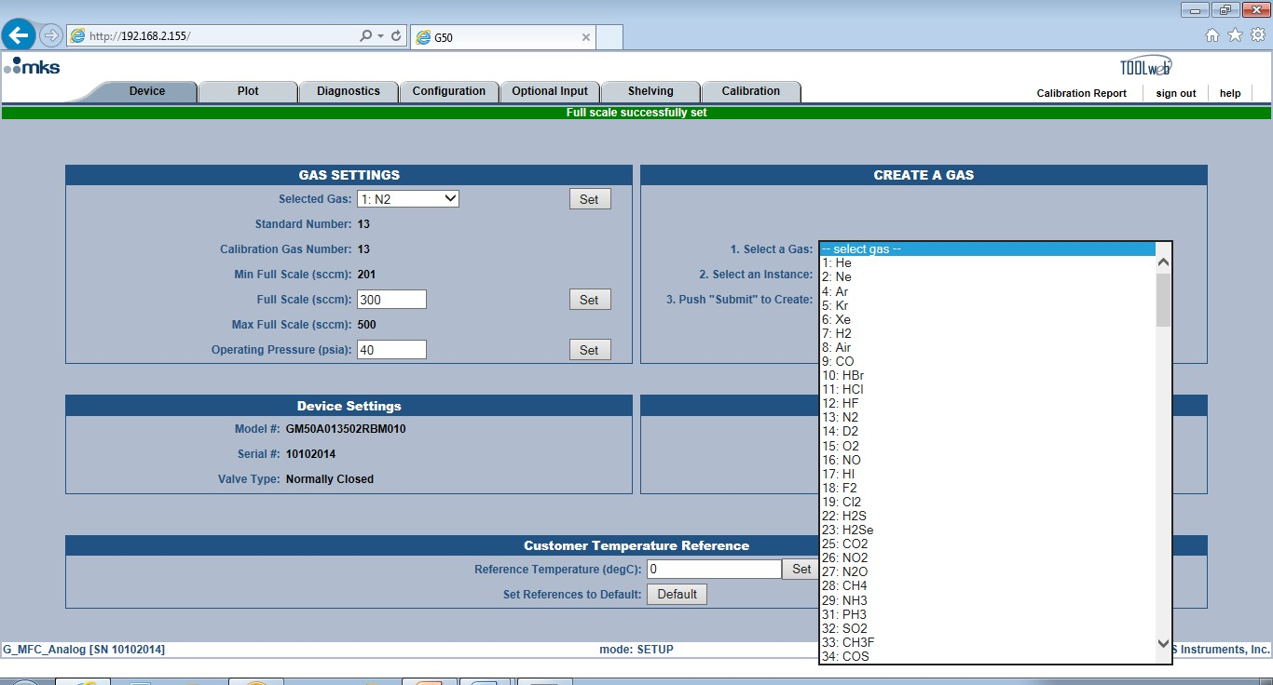

* After selecting a Gas, select an unused instance in which to build the new calibration table

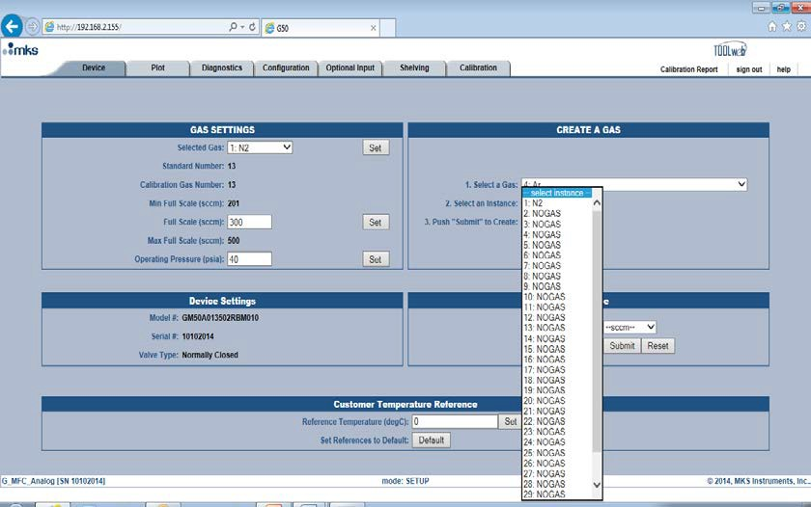

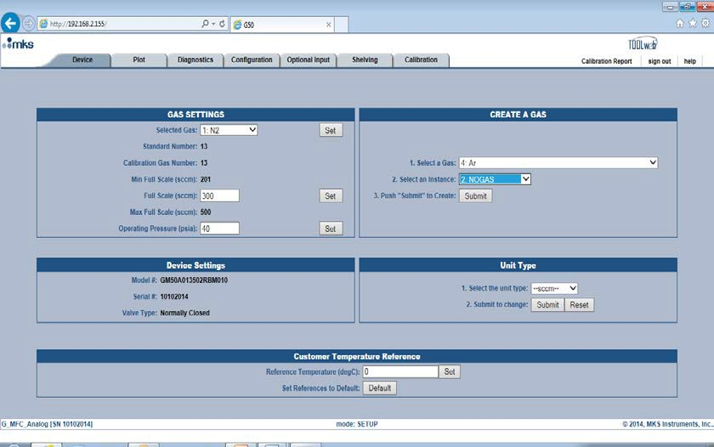

* Hit Submit. It takes approximately 40 seconds to complete the process. After successful completion, the new gas created will listed as the current gas selection in Gas Settings. The Full Scale may be re-ranged to values dependent upon the gas type.

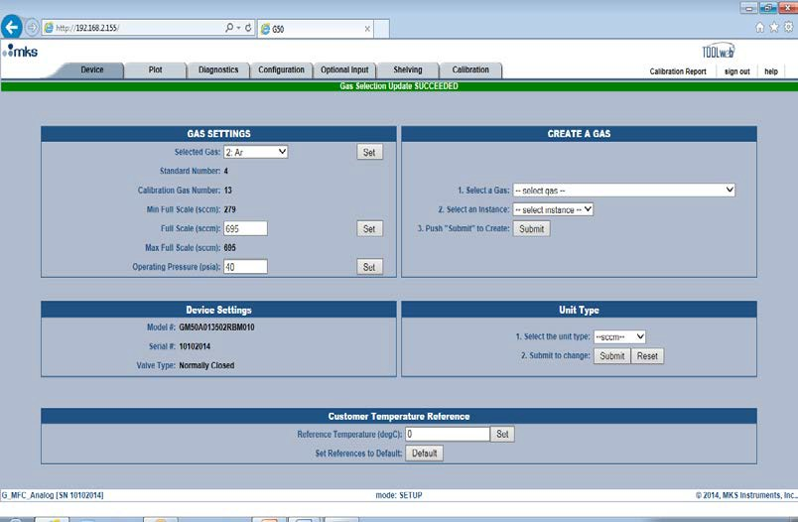

### Special Application Note:

**While the device is going through it internal steps to create a new gas table routine, do not recycle or un-power the MFC. This will corrupt the flash and cause a catastrophic failure to occur on the MFC.**

**Unit Type:**

* MKS MFC’s uses sccm (standard cubic centimeters per minute) as it default data type. Utilizing the pull down menu under <Unit Type>, a user can select other flow units for a MFC.

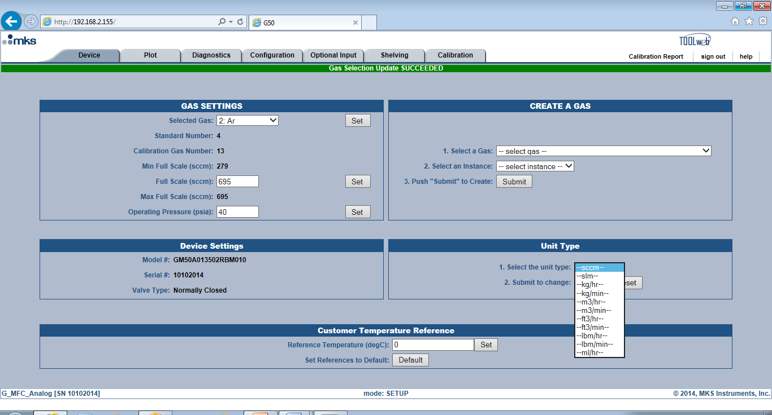

* Once the flow unit type has been selected, hit <Submit> to change.

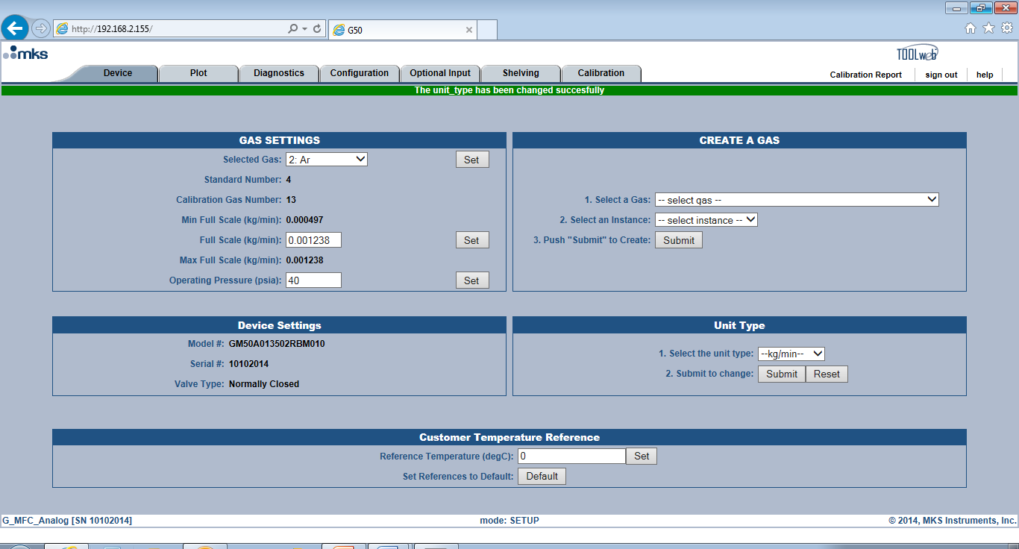

* Once the unit type has been successfully changed, the Full Scale value is automatically converted into the new units.

### Customer Reference Temperature:

* Conversion from Volumetric Flow to Mass Flow requires the MFC manufacturer to select Standard Temperature and Pressure Condition (STP) references in order to calibrate the MFC.

#### MKS uses STP conditions of 760 Torr (1 atm) and 0oC (default).

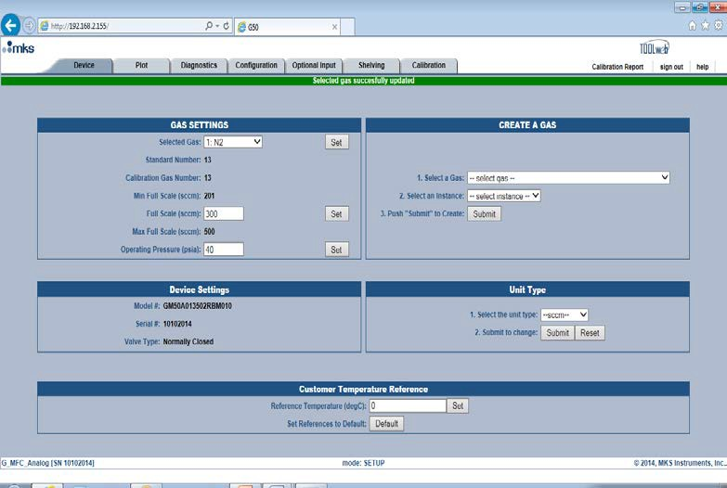

* Other MFC products or technologies used in an application or as secondary standards could be calibrated using a different reference temperature (20oC and 25oC are other common reference temperatures used in industrial applications)
* This Browser feature allows the customer to be able to setup and install an MKS Flow Control Product in an application where the current products being utilized are calibrated to a different reference condition by entering the correct reference temperature and hitting the <Set> button.

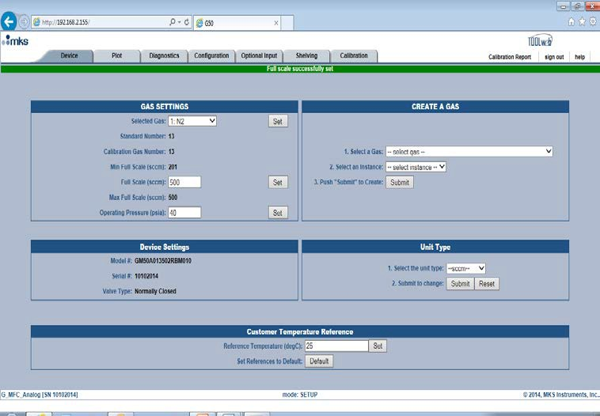

# Example:

What is the effect of using an MFC that is calibrated at STP conditions of 760 T/ 0oC to replace one that is calibrated to STP conditions 760 T / 25oC?

|  |  |
| --- | --- |
| **MFC Set point for MFC X(sccm)** | 500 |
| **Reference Temperature for MFC X (oK)** | 298.15 |
| **Reference Temperature for MKS MFC (oK)** | 273.15 |
| **Reference Pressure (atm)** | 1 |
|  | |
| **Calculated MFC Flow for MKS Flow Controller** | 458.07 |

In this example MFC X is currently being used in an application and has been calibrated to a reference temperature of 25oC (298.15oK). Installing an MKS Flow Controller as a replacement would result in 8.4% less actual flow for the same MFC set point of 500 sccm.

This Browser feature would allow the user to change the reference temperature and scale the MFC actual flow to eliminate this difference.

## Setup Mode: Plot Tab

* The plot page on the Browser provides an excellent diagnostic tool to evaluate the performance of the MFC during actual application steps or independently for bench testing as a pre-check prior to installing the MFC in an application.

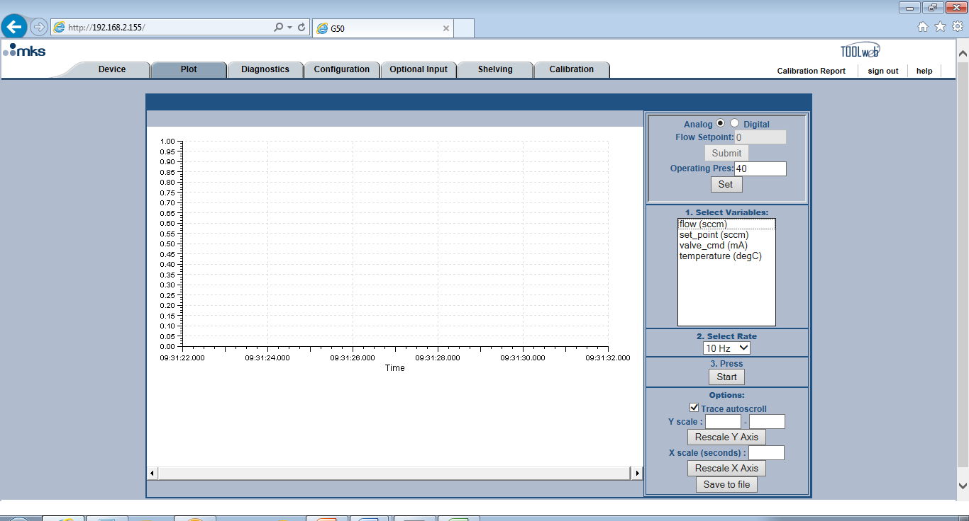

* The variables that can be graphed on the plot page can be selected by holding down the control key and left click on each individual entry to highlight.

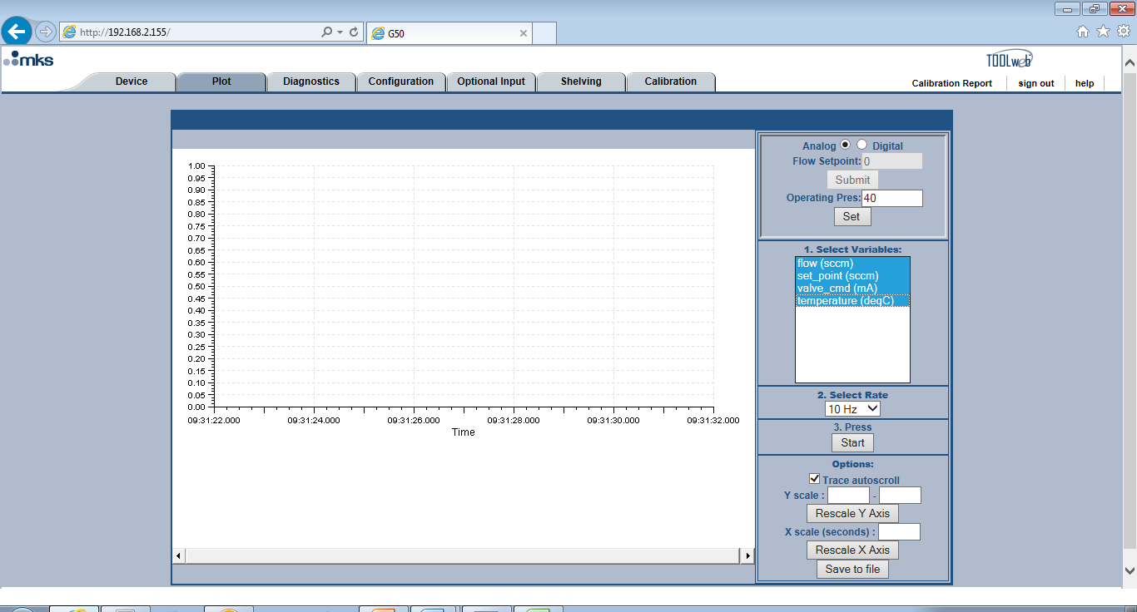

* Select the data collection rate using the pull down menu. A value of 10Hz, or 10 reading per second, is the standard default. For more resolution the maximum data collection rate is 100 Hz.

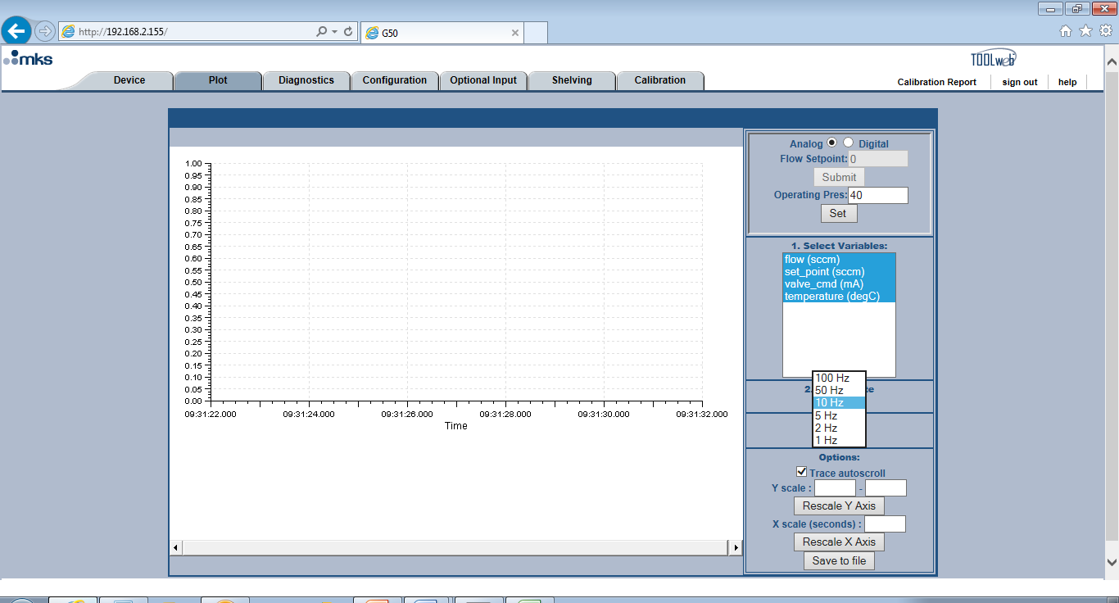

* Push <Start> to activate the plot page for the variables selected.

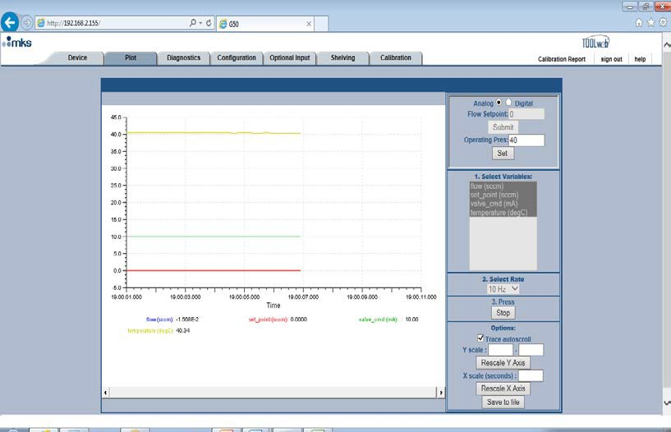

* In the screen shot above all variables have been selected and the actual readings are listed below the graph.

#### Note: Sending Set Point over Ethernet:

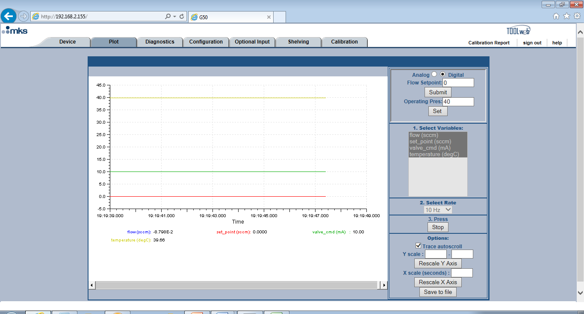

* The Analog MFC above has been toggled to the “Digital” mode and can now accept a set point via Ethernet. Type in the set point value and hit <Submit>.

Special Applications Note: There will be some slight variations depending on the device configuration in order for the device to accept and respond to an Ethernet set point.

1. **Analog (9 or 15 pin)** – Toggle the selection from Analog to Digital at the top of the Plot page to send a set point over Ethernet communication.
2. **DeviceNet** – Already a digital protocol, however the MFC must **not** have a polled connection for the MFC to accept a digital set point over the Ethernet port.
3. **RS485** – Already a digital protocol, no special setup for in order to send set points through the Ethernet port to the device.
4. **Profibus** – Similar to DeviceNet in that the MFC should be powered but not connected to the Profibus network in order for the MFC to accept an Ethernet set point command.
5. **Ethercat** - Already a digital protocol, no special setup for in order to send set points over Ethernet.

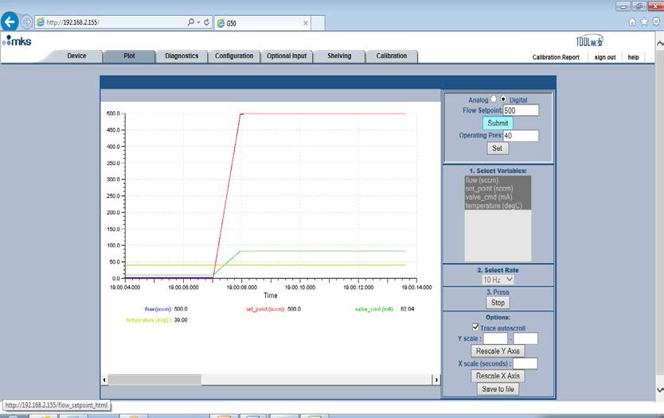

* Device accepts and responds to a 500 sccm set point.
* After stopping the device data collected during that period of time can be saved in a .csv format that can be analyzed latter in excel spreadsheet.

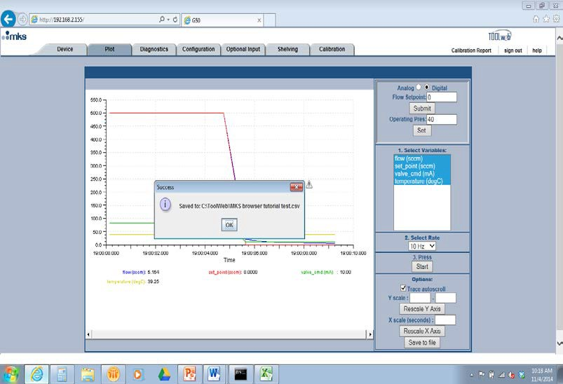

##### *Special Instructions about Plotting and saving Data:*

* The plot page requires a java applet to run and plot data on the graph.
* The plot page is designed to work with **Internet Explorer**. Over time the plot has been used with various versions of Internet Explorer and XP/ Windows 7 operating systems. For the plot page to function properly we recommend using Windows 7, Internet Explorer 11, and java version 7 or higher.
* The java applet has security requirements that must be addressed before the plot page will open. Details on how to address this issue are described in detail in **Appendix A**.
* Saving the data also requires some special setup procedures. Details on how to save data are described in **Appendix A.**

#### Setup Mode: Diagnostics Tab:

* The Diagnostics tab allows the user to run basic pass/fail tests on the flow and temperature sensor. These tests consist of taking 100 readings from the flow and temperature sensors and statistically analyzing the data to make sure the outputs are valid.

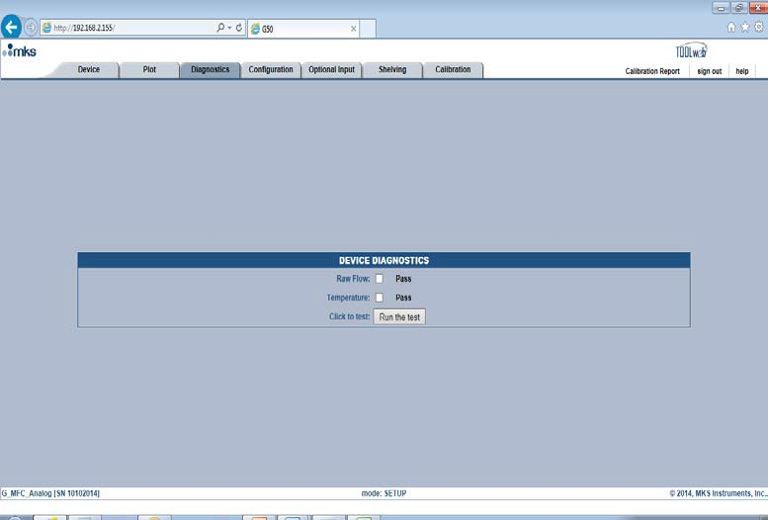

* To run the test check the <Raw Flow> and <Temperature> box. Hit the <Run the Test> button
* After completion of the test the bar at the top will provide pass / fail result.

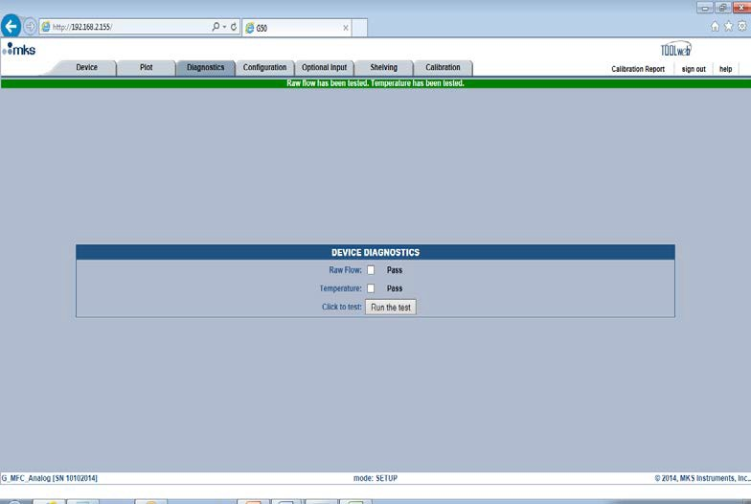

# Setup Mode: Configuration Tab

* The Configuration page has several features that can be beneficial to assist the user in setting up the MFC and allowing access to upgrade the firmware of the device at some future date should the need arise.

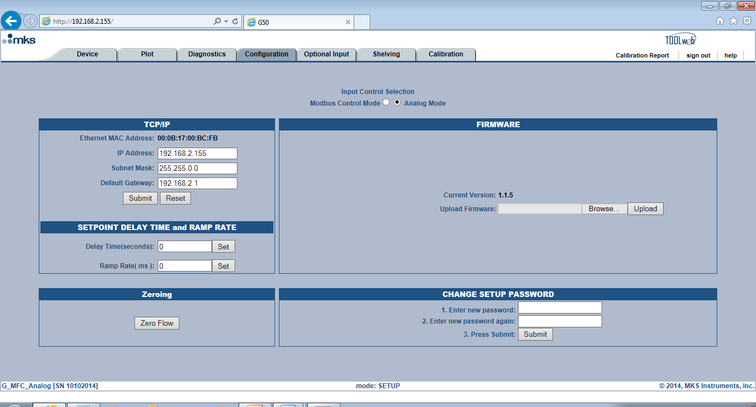

#### Input Control Selection – Analog to Modbus :

* A selection at the top of the page allows the user to change the control mode from Analog to Modbus TCP / IP. Control of the device after toggling this button is via Ethernet. The MFC will remain in this digital mode (even after power cycling) until the device is toggled back to Analog on this page.
* MKS has developed a Modbus specification document that describes which MFC functions are supported when using this communication protocol.
* A simple Labview VI and the Modbus Labview Drivers have been documented and are available to customers upon request.

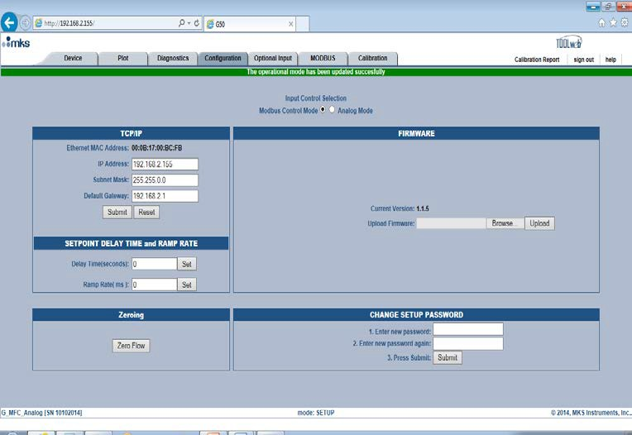

* Once converted to Modbus, the device will remain in a digital mode and communicate via the Ethernet port (even after power cycling) until it is toggled back to Analog on the <Configuration> page.

#### Changing the IP Address of the MFC:

* On the left had side of the configuration page the IP address of the MFC is displayed.
* Changes can be made to the IP Address on the configuration page. In order to open a Browser tab for more than one MFC, each MFC must have a distinct and different IP Address.
* Changes in the IP Address can be made by altering the current number and hitting <Submit>.

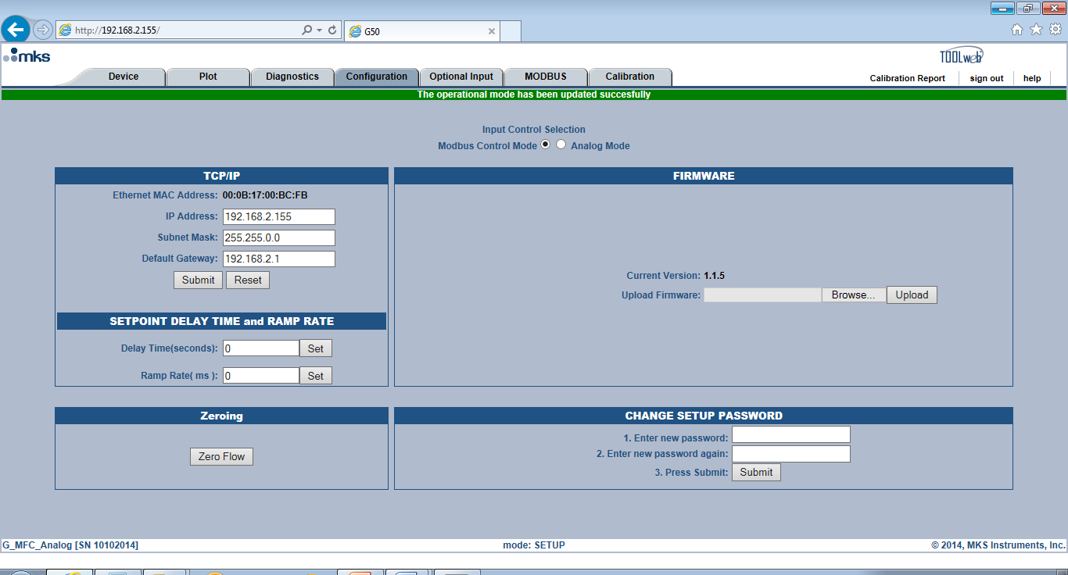

#### Set Point Delay and Ramp Rate:

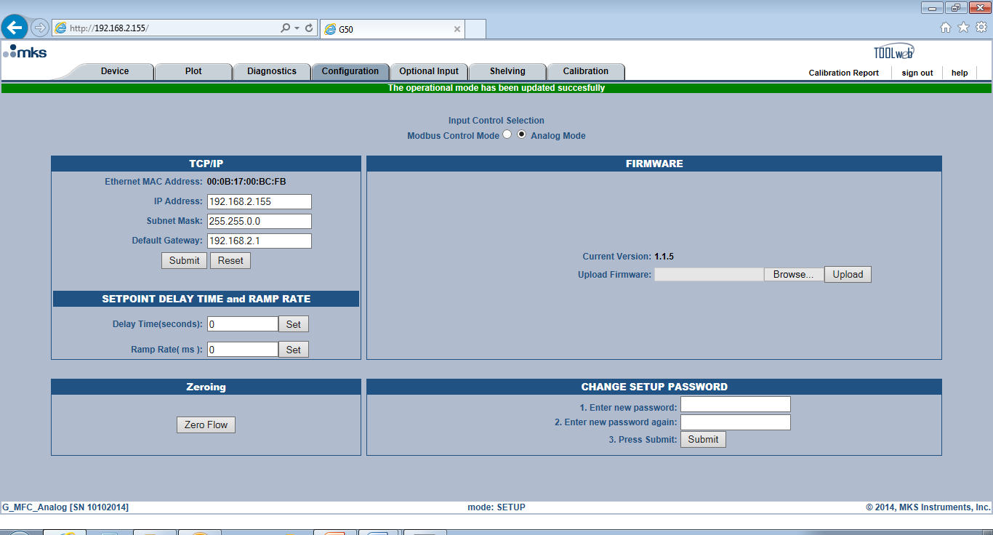

* Two functions available to the user on the <Configuration> page that alter the transient response of a MFC are set point delay and set point ramp rate.

#### Defaults for both functions “as shipped” from the factory are 0.

* 1. Delay time, which is set in the box and initiated by selecting <Set> is expressed in ***seconds***.

#### Applications Example:

This function has been used successfully in situations where the MFC is installed in a system and a set point is given to the MFC at the same time another action is happening (such as actuation of a valve). The result of this timing issue is the MFC fails to meet expected transient response characteristics. A very short delay before the MFC responds to the set point allows the perturbation to be eliminated and the transient response to set point to meet published MFC specifications.

* 1. Ramp Rate, which is set in the box and initiated by selecting <Set>, is expressed in ***milliseconds***.

#### Applications Example:

The G series MFC has been designed to replace MKS legacy products. In terms of performance the digital design of the G series, and it control algorithm, results in a much faster transient response to set point. This could result in changes to the current process application that could be detrimental to the final product. The ramp rate function could be used to mimic the

response characteristics of the current MFC so that actual changes to the current process would not be necessary.

#### Zeroing the MFC:

* Zeroing the MFC correctly is one of the most basic requirements in order for the MFC to meet and maintain published specifications for gas calibration accuracy.
* The MFC can be zeroed in a couple of ways
  + 1. Zero button on the top of the MFC (hold the button down for 3 sec)
    2. Hit the <Zero> button at the bottom of the configuration page

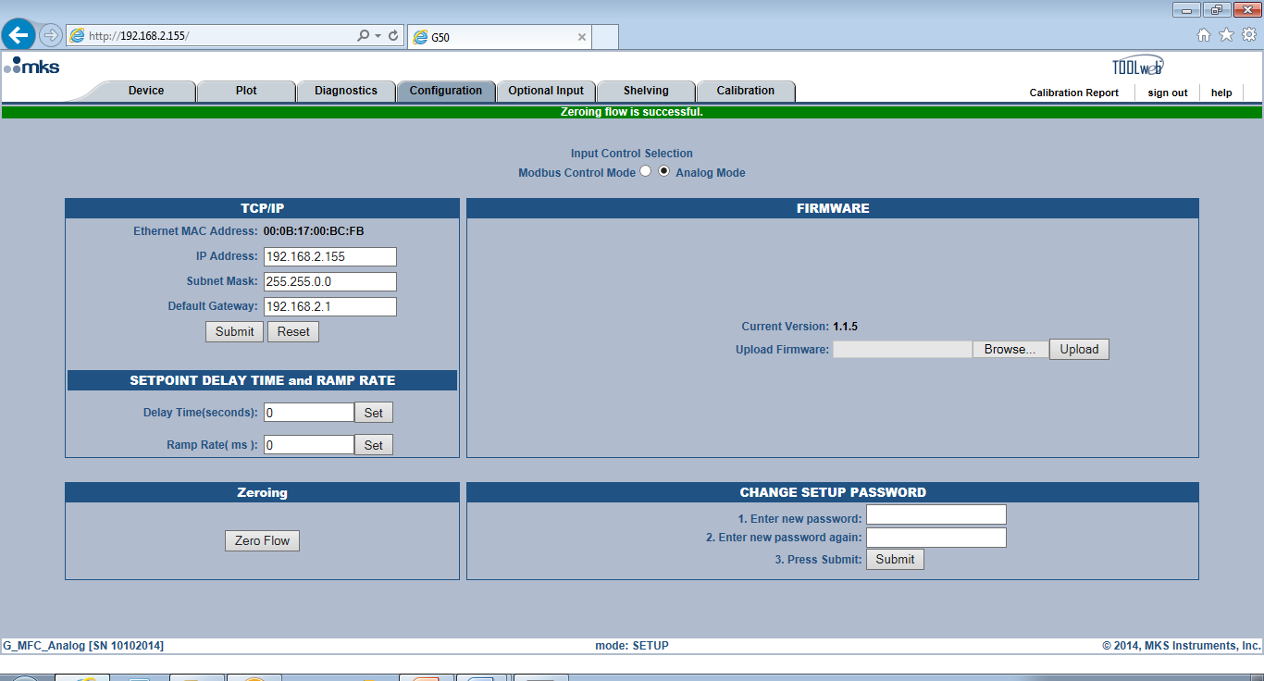

##### *Recommended Techniques for Zeroing an MFC:*

* There are a few fundamental considerations when zeroing an MFC

1. The device should be installed in the orientation and within the environment in which is going to be used.
2. The MFC should be powered and allowed to reach a stable temperature.
3. Before a zero is issued any pressure differential across the MFC valve has to be eliminated (equalization of the pressure upstream and downstream of the MFC).

* Technically an MFC can be zeroed at atmosphere, vacuum, or at the operating pressure to which the MFC will be exposed to during operation.
* MKS recommends zeroing the device at the operating pressure of the MFC.

Depending on the gas panel configuration, this may be done by one of the following procedures:

# System is at operating pressure and has upstream and downstream positive shut off valves

* 1. Close the upstream valve.
  2. Close the downstream valve.
  3. Open the MFC’s control valve (Send MFC a full scale set point or use valve override).
  4. Allow pressure across MFC to equilibrate and the flow output to stabilize at zero.
  5. Close the MFC’s control valve.
  6. Wait one minute and adjust the zero using one of the methods specified for the device I/O type.

# For systems at operating pressure with downstream valve only

* 1. Close the downstream valve.
  2. Open the MFC’s control valve (Send MFC a full scale set point or use valve override).
  3. Allow pressure across MFC to equilibrate and the flow output to stabilize at zero.
  4. Close the MFC’s control valve.
  5. Wait one minute and adjust zero using one of the methods specified for the device I/O type.

# For systems with upstream valve only/ system at atmosphere or under vacuum

* 1. Close the upstream valve.
  2. Open the MFC’s control valve (Send MFC a full scale set point or use valve override).
  3. The MFC may be evacuated to vacuum or exposed to atmosphere on downstream side. For either case, the downstream pressure must be kept constant to insure there is no pressure drop across MFC.
  4. Allow pressure to equilibrate across MFC.
  5. Close the MFC’s control valve.
  6. Wait one minute and adjust zero using one of the methods specified for the device I/O type.

#### Updating MFC Firmware Revision:

* The current version of MFC firmware is displayed on the <Configuration> page. Updating the MFC with a new version of firmware is simple process to complete using the <Update Firmware> box.

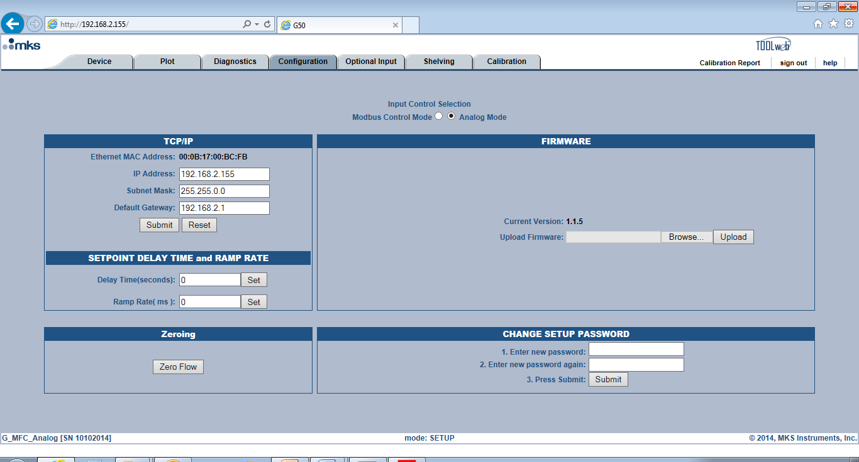

Procedures for Updating the MFC Firmware Revision:

1. Open the Web Browser to the <Configuration> tab while in the <Setup> Mode.

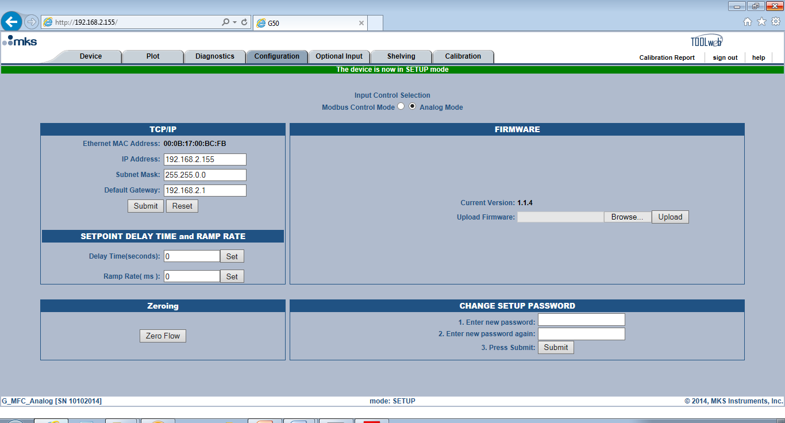

1. Left click on the <Browse> button and locate the new version of Firmware that is to be loaded into the MFC.

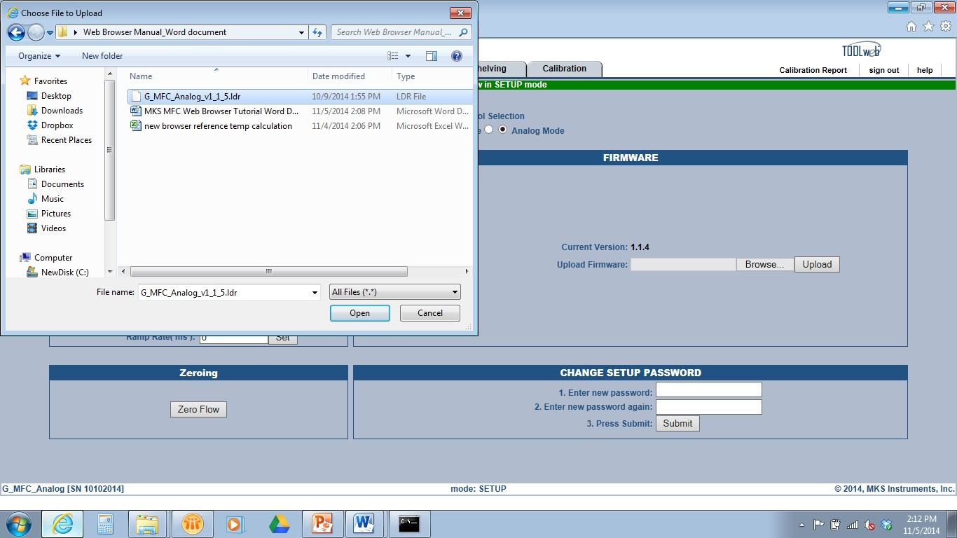

1. Once selected hit <Open> to transfer the firmware file into the Browser.

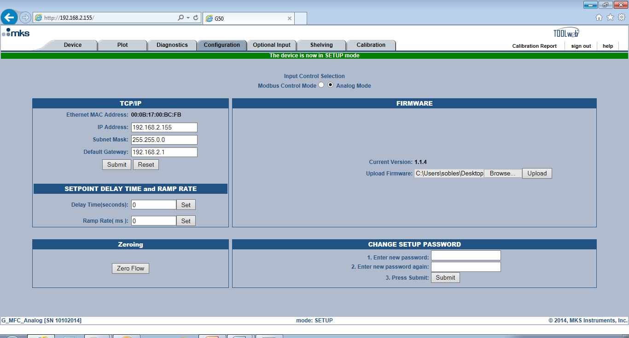

1. Hit <Upload>. The process to upload new firmware takes about 30 to 40 seconds to complete. After completion, the Browser will ask the user to reset (power cycle) the device.

**Special Applications Note**

**While the MFC is in the process of completing the Firmware Upgrade do not remove the power from the device. If the power is interrupted while the device is saving to its flash memory, the flash will be corrupted and the MFC will experience a catastrophic failure.**

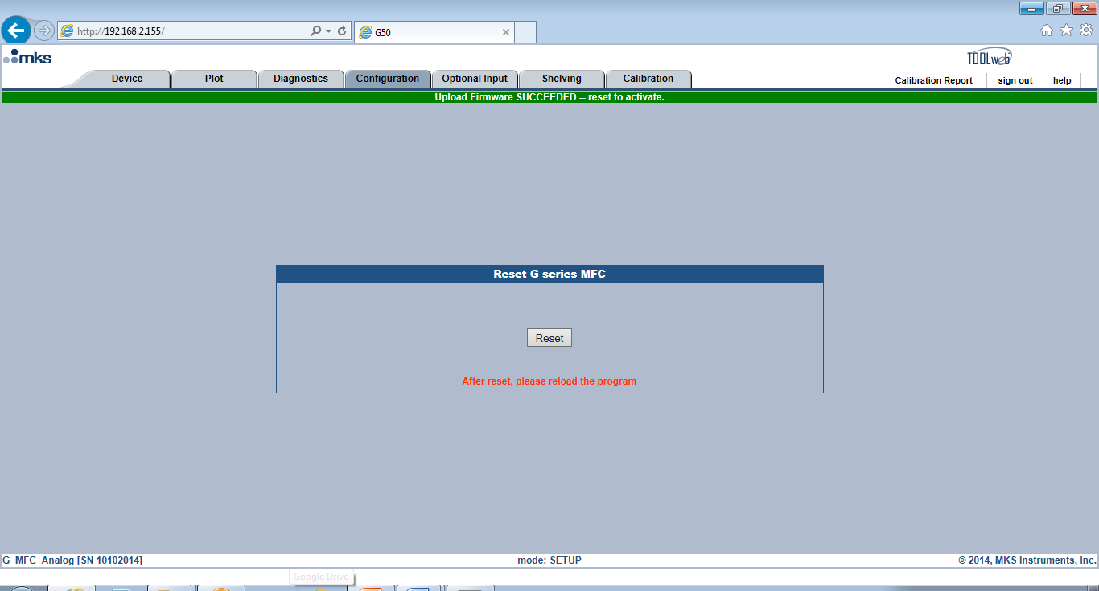

1. Hit the <Reset> button. Wait 15 seconds before continuing to the next step.
2. Verify that the new version of Firmware loaded correctly by re-freshening (or closing and re- opening) the Browser and opening the <Configuration> page (Setup Mode).



1. In order to complete the process of upgrading the firmware of an MFC any new parameters or changes to existing parameters being introduced into the MFC from the upgrade must be initialized in the gas table files that exist on the MFC**. See Appendix B for detailed instructions on how to finish updating the gas tables that are on the MFC.**

#### Changing the Setup Mode Password:

* The password to get from the Monitor Mode to the Setup Mode can be changed from its default

<config> to something that may be more familiar to the MFC user.

* From the <Configuration> page enter the new password into the appropriate box at the bottom of the page.
* Press <Submit>

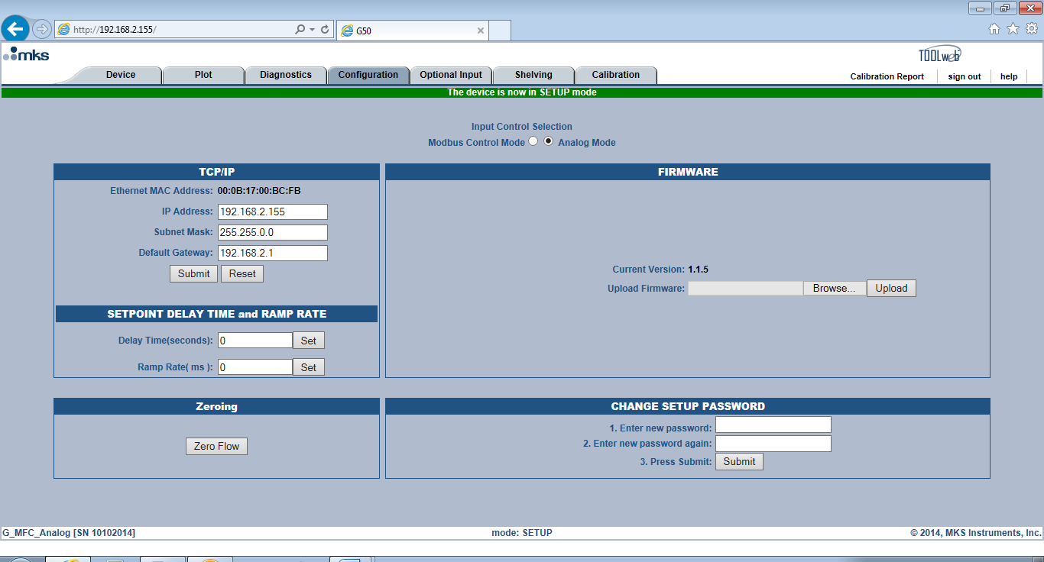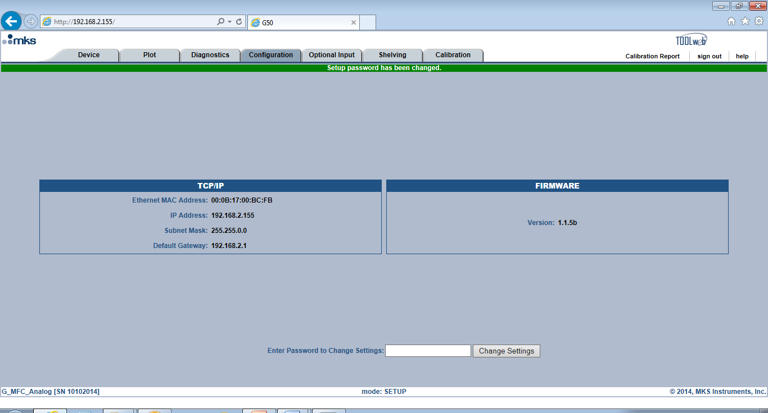

* Re-enter the new password and hit <Change Settings>
* After changing the password the user has to take care to remember the new password.

#### If the password is lost or forgotten, there is no way to recover this information on the MFC.

**Setup Mode: Optional Input Tab**

1. Optional Input provides the user with the ability to take an external control signal from a pressure transducer and feed that signal back into the MFC through Pin 10. Response to a set point then uses that output signal from the transducer to drive the MFC valve, and modulate gas flow such that the Pressure in the volume is controlled to the application pressure.
2. Using this mode relegates the MFC to controlling the Pressure output as determined by the set point. Flow under these control conditions is independent of the set point being delivered to the device.
3. This control feature of the MFC is available only with Analog 15 pin D devices.
4. The MFC allows the user to select an Upstream or Downstream pressure control scheme depending upon the application.

#### Basic Wiring Diagram for Optional Input:

* **Baratron to MFC**: Two wires

1. Transducer pressure output Pin 1 ------------ MFC Optional Input Pin 10
2. Transducer pressure return Pin 8 ------------ MFC Signal Common Pin 11 or 12



Pin 11 or 12

Pin 7

Pin 5

Flow

MFC

MKS Transducer

MFC Pin 11 or 12 – Signal Return

Transducer Pin 1 – Pressure out

Transducer Pin 8 – Pressure Return

MFC Pin 10 – Optional input

Pin 8

41

**MFC Requirements**

1. Power – Pin 7
2. Power common – Pin 5
3. Set point – Pin 8
4. Signal common – Pin 11 or 12

**** Pin 5 and 12 should be connected or jumped together

### Optional Input Configuration via the Web Browser:

* The web browser is used to enable the Optional Input function

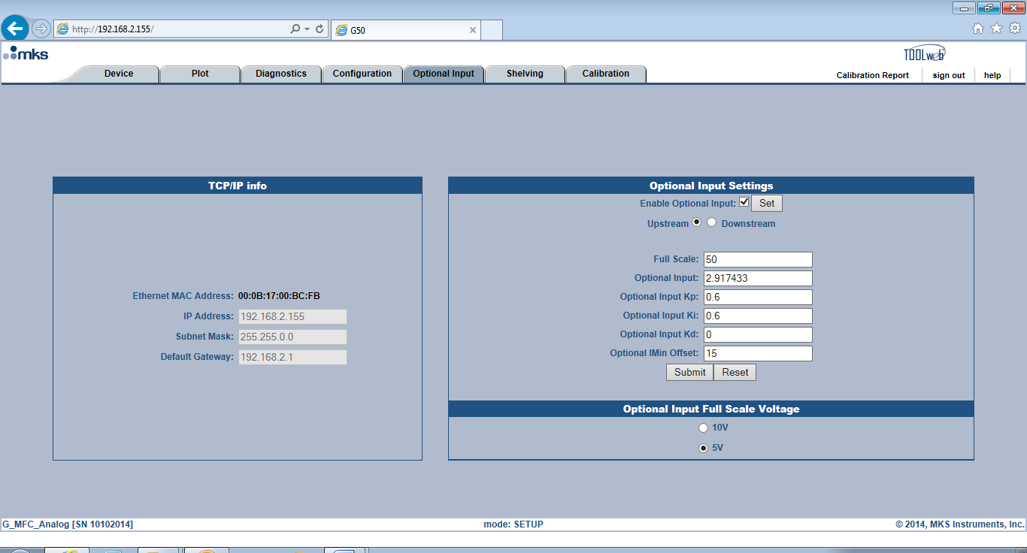

* Setting up the MFC requires that Optional Input is enabled by checking the enable box and hitting <Set>.
* Optional Input may be set for Upstream or Downstream Control as determined by the application.
* Full scale and Full Scale voltage of the Transducer must be defined.
* Response to set point can be adjusted using Optional Input Kp and Ki. These values can also be adjusted on the <Plot> page as shown below.
* To save changes made to define the Optional Input setup, select <Submit>.

### Optional Input Plot Page:

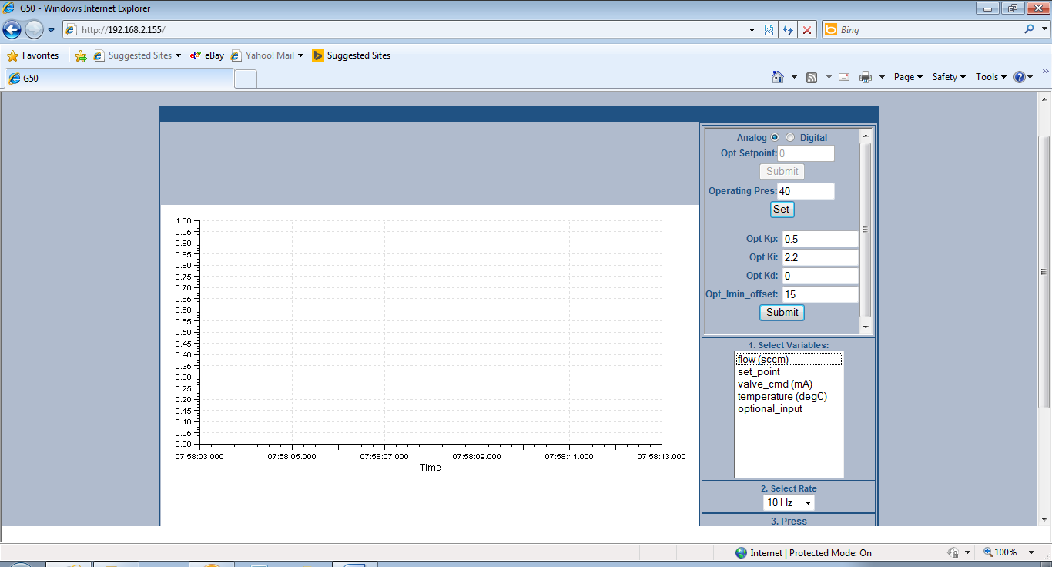

**Notes:** The key parameters for tuning an Optional input pressure response is **Opt_kp** and **ki**.

**Opt_imin _offset** is a factor that is applied to the valve command minimum (valve current starting point) to effectively lower the command min by the value of the offset. For example, an Opt_imin_offset of 15, the default, would shift the valve command minimum down by 15 mA.

In some pressure control circumstance, normally associated with trying to control to very low at optional input set points (trying to control at very low pressures) the following condition can occur:

#### MFC command min (valve starting point in flash memory) > valve_cmd at set point (valve mA at steady state for a given set point)

If this condition is true, the MFC is going to essentially start at a higher current than necessary to actually achieve set point and the response is going to overshoot when the set point is initiated. This parameter can be used to correct overshoot in this very special circumstance.

#### The default value, 15, should be adequate for the majority of optional input control scenarios and does not need to be changed for the application.

##### *Optional Input Plot Page Example*

* Pressure control data collected, saved from the plot page, and transferred into an excel spreadsheet is presented in the graph below:

optional_input

Valve_cmd (mA)

Set_point

Flow (sccm)

80

70

60

30 40 50

**Time (sec)**

20

10

500.00

400.00

300.00

200.00

100.00

0.00

0

600.00

10000.00

9000.00

8000.00

7000.00

6000.00

5000.00

4000.00

3000.00

2000.00

1000.00

0.00

**MFC Configured for Downstream Pressure**

**Control using Optional Control Input**

**Flow (sccm)**

**Set Point (T), Optional Input (T), Valve (mA)**

**Setup Mode: Shelving Tab**

* Shelving is a selectable, user defined function for Analog devices that can convert an Analog set point into a Digital set point, thereby eliminating potential offsets due to A/D conversion within the electronics of the MFC or noise that can be associated with analog electronics.
* The conversion to a digital set point occurs when the user assigns set points to the Shelving table. The Browser calculates a voltage for each of the set points once the table has been submitted.
* When Shelving is enabled the controller takes the analog set point input and determines if is within one of the Shelving table voltages (+/- the settling band set by the user).
* If the set point meets the above criteria, then as long as the set point remains within the set point band, an exact digital set point controls the input to the MFC.

#### Setting up the Shelving Function via the Web Browser

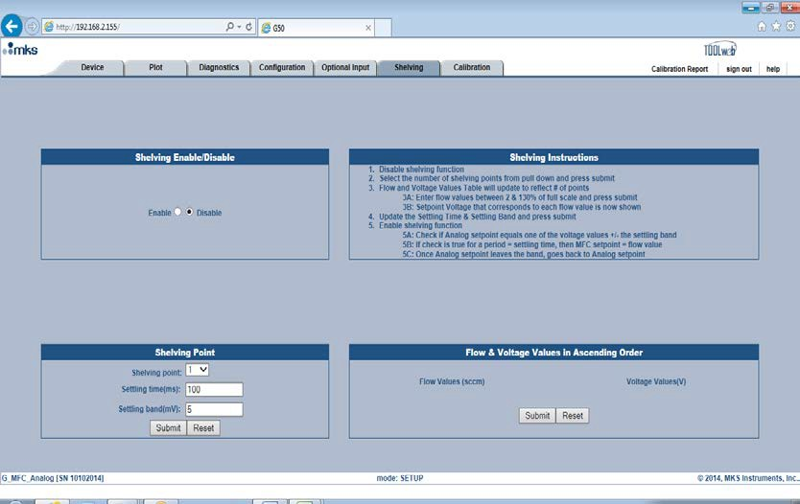

##### *Selecting Shelving Points and Parameters*

* The <Shelving Enable/Disable>selection should be set to <Disable> prior to setting up the Shelving parameters.
* Determine the number of <Shelving > points to be assigned to the table.
* The Settling time represents the time period allowed prior to analyzing the flow read back voltage to see if it is within the Settling band and the change from an analog to precise digital

signal can be instituted. If necessary settling time and settling band can be changed from default values for the selected points.

* Once the pertinent information has been entered hit <Submit>

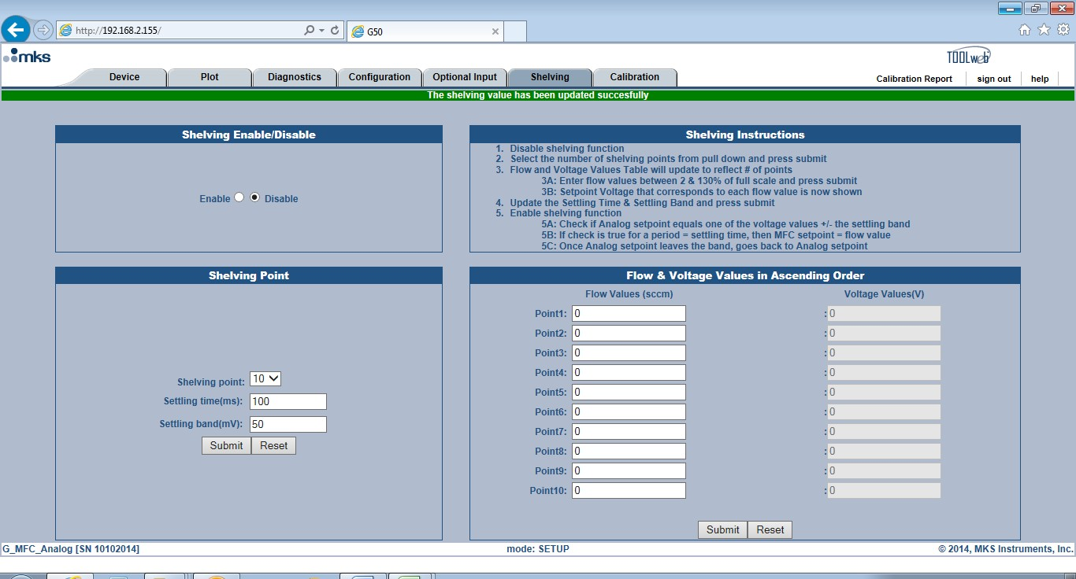

##### *Populating the Flow Values Table to define Set Points for Shelving Function*

* The flow and voltage values table expands to coincide with the number of shelving points selected.
* Enter the set points into the table. Voltage values for each set point are calculated and populated in the table.

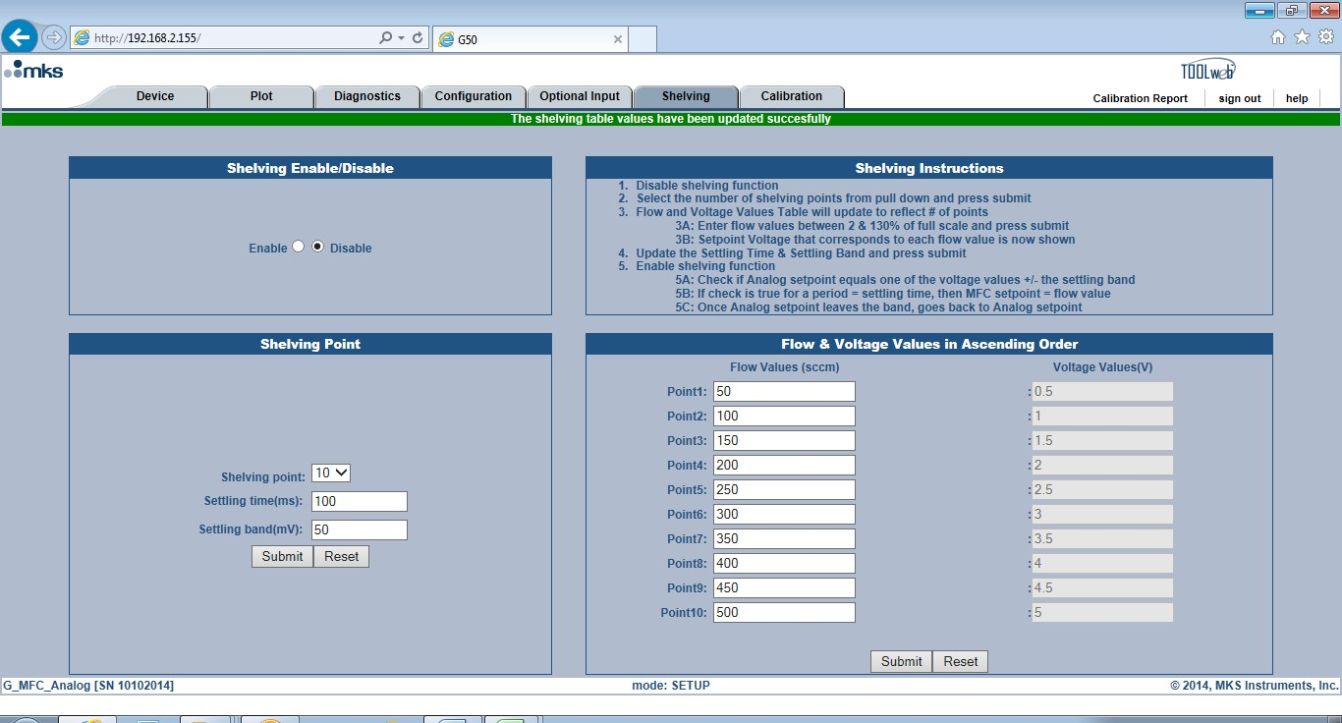

* To initiate this function select Enable.

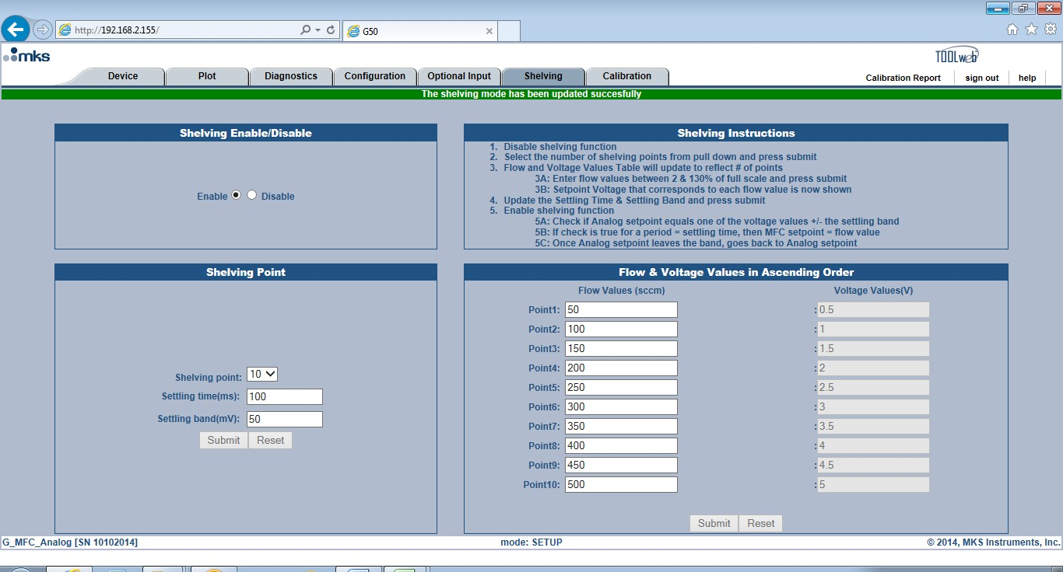

*Shelving Function Demonstration*

* Shelving Function is set up such that 1 second after the set point is initiated, and if the set point is within 100mV of the set point voltage, the set point will be converted from Analog to Digital.

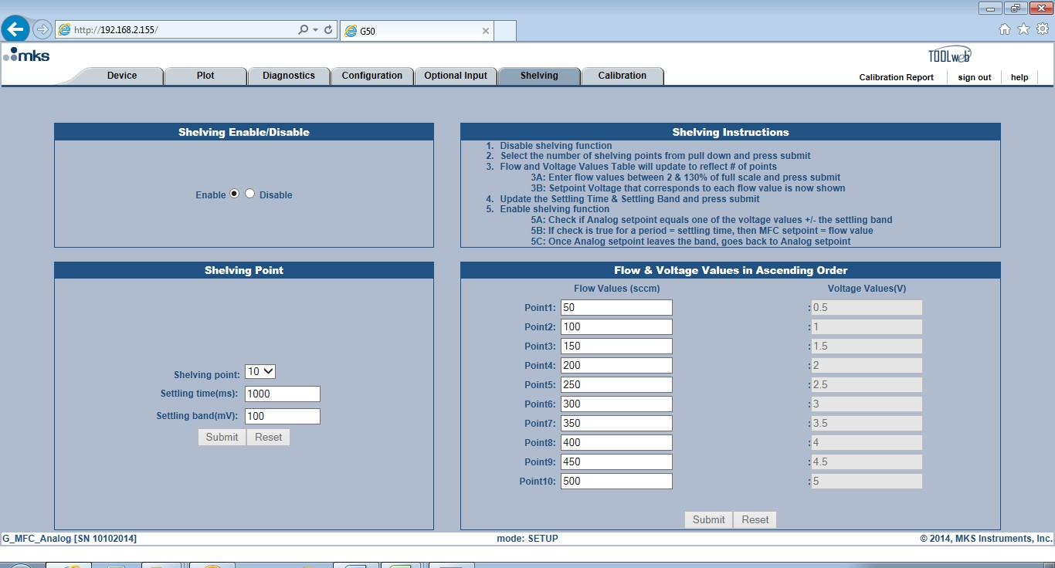

* 10% FS set point given to MFC. Actual analog set point is equal to .496V (40 mV offset). The set point is within the 100mV band so after 1 second, the set points shifts from .496V to .5V. MFC responds and flow control to desired precise value equal to 50 sccm.

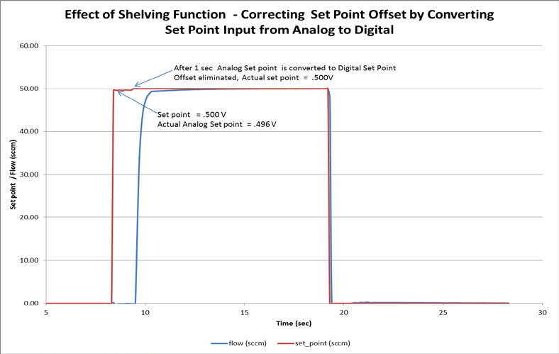

## Setup Mode: Calibration Tab

* The Calibration page (also referred to as External Calibration) allows the user to make adjustments to a calibration table associated with a nameplate gas based upon flow accuracy data generated by the user’s internal flow accuracy standard (secondary MFM standard, Chamber Rate of Rise, etc.).
* Modification of a gas table using this technique affects only the instance that is currently selected. It is important to verify the current gas table selected matches the name plate gas that is to be modified using the External Calibration page.
* Each gas table on the MFC can have its own, individual External Calibration Table.

### Special Application Note:

#### It is recommended that the user go to the <Device> tab and make sure the name plate gas being selected for modification is set to its maximum full scale value before determining the set points to be run to determine <Actual> flow accuracy. After collecting all the appropriate data and enabling the table, the user can return to the <Device> Tab and re-range the full scale of the gas table as necessary.

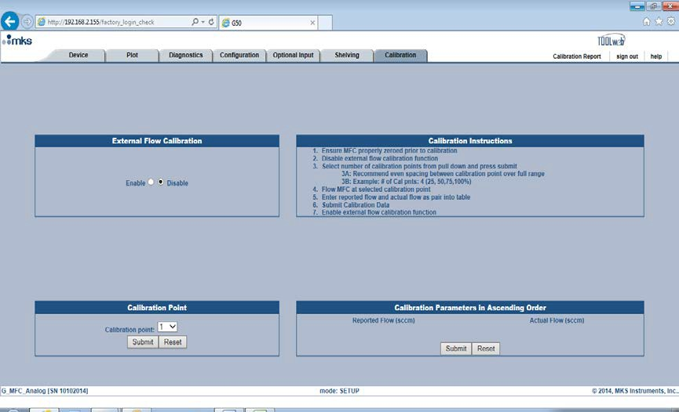

**Selecting Calibration Points:**

* The format is similar to the Shelving page. First select the number of calibration points. The more points used the better the mathematical fit for the shifted or new calibration curve.

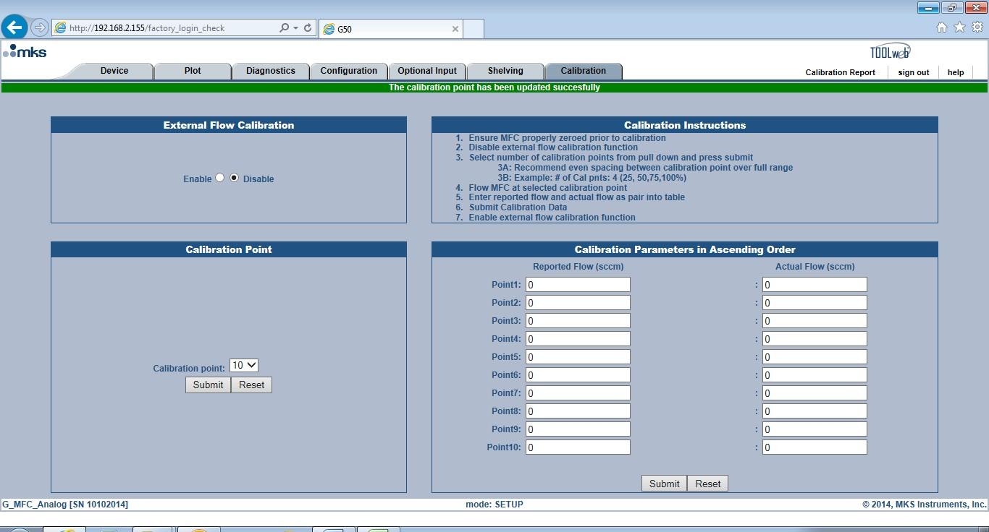

#### Completing the Calibration Parameters Section:

* Fill in the table for the Reported Flow. Note that the values must be non-zero and in an ascending order.

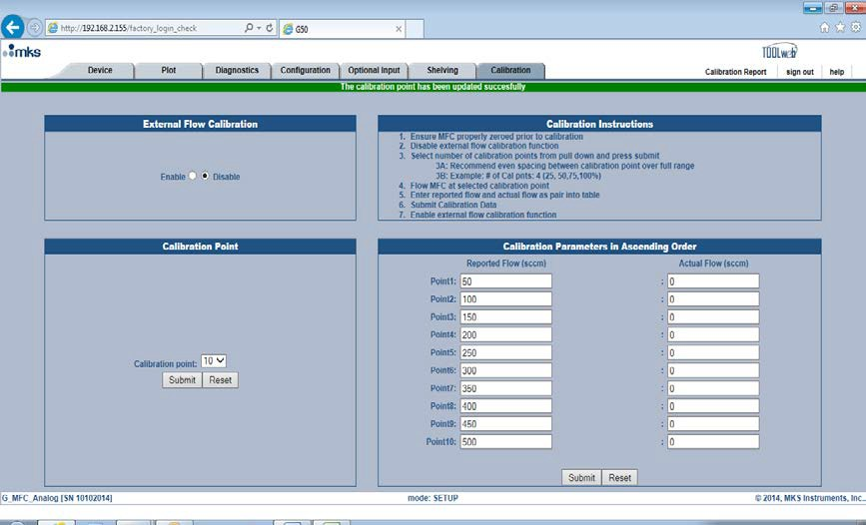

* Run each data point using internal standard and determine the <Actual> Flow. Put the values for each set point into the table. After entering the values, hit <Submit>. If all the criteria are met the new table will be accepted.

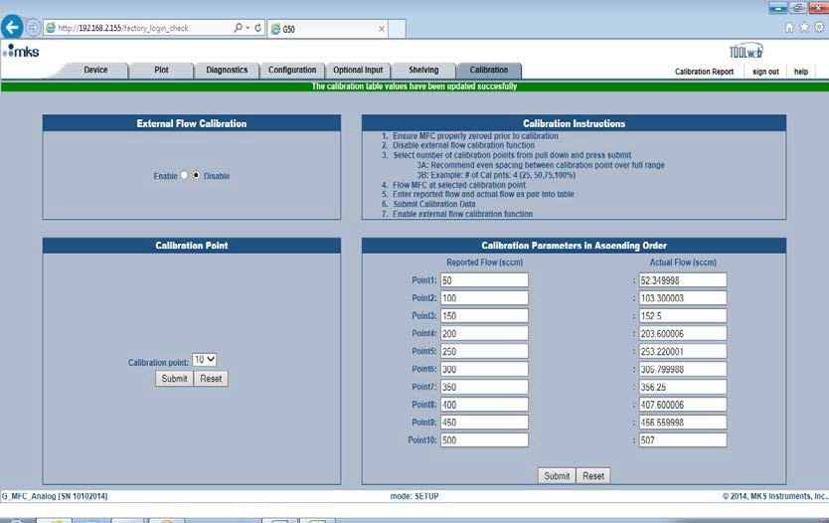

#### Activating the Modified Calibration Table

* To make the new table active for the gas instance selected, select <Enable>.

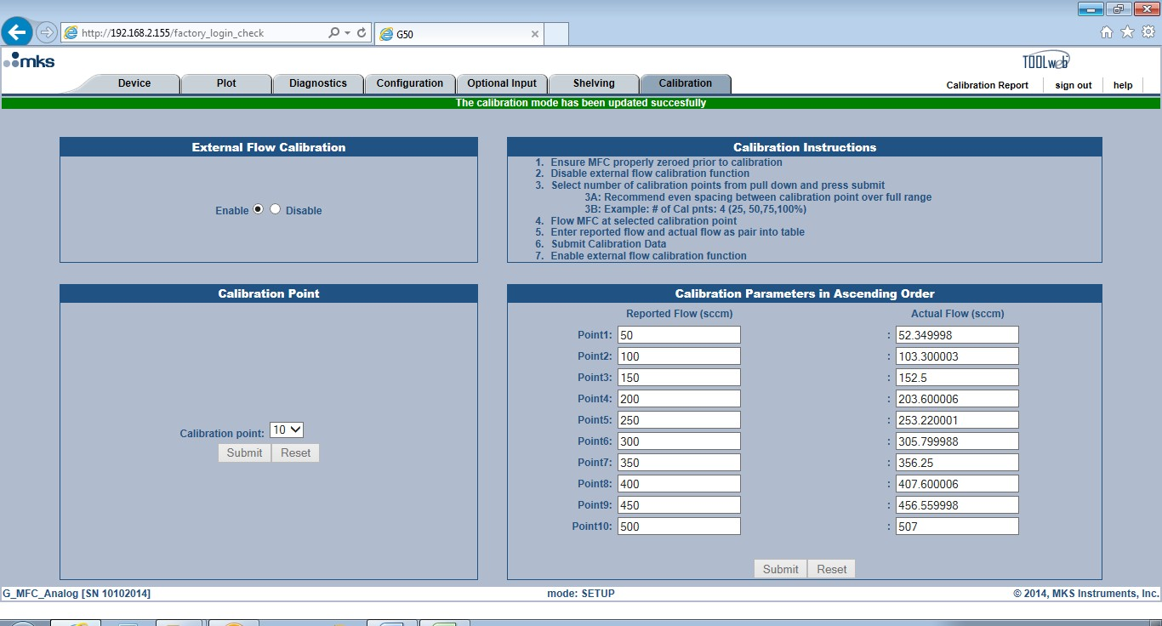

* After enabling the table, the ability to make changes and submit these changes is not available unless <Disable> is selected.

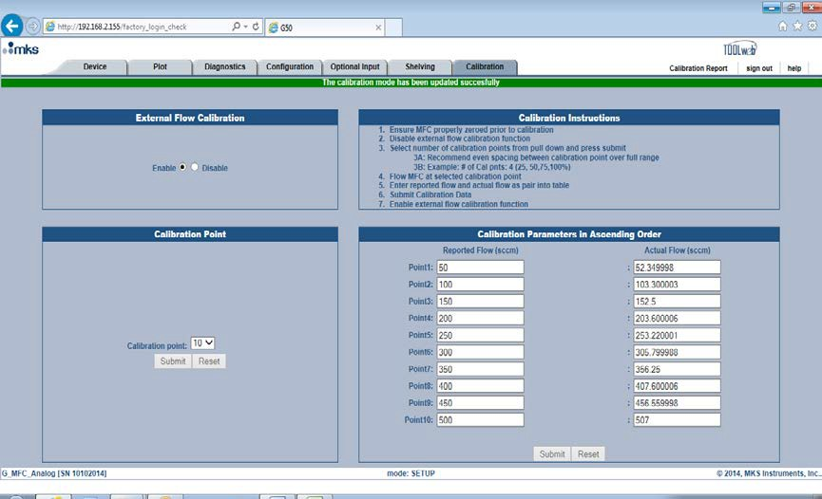

# Appendix A – Activating the Plot Page and Saving Plot Data

* Three steps must be completed to be able to actively plot selected MFC parameters:

1. A Java applet must be allowed to run in order for the plot page graph to become active.
2. In order to save data, a special folder called ToolWeb must be created in the computers local C Drive.
3. A special Java policy document must be put into a Java security folder located in C drive before being able to successfully save data to the ToolWeb folder.

## Internet Explorer:

* The Browser plot page works only with Internet Explorer.
* MKS recommends IE version 11. Older versions may or may not work with latest java installation.

## Java Version Requirement and Download:

* Java version 7 or higher must be downloaded to the computer
* If necessary, go online to Java.com and download the latest version available on the Java website.



## Java Security Document Placement:

* Once downloaded, follow the file path to locate the new Java folder

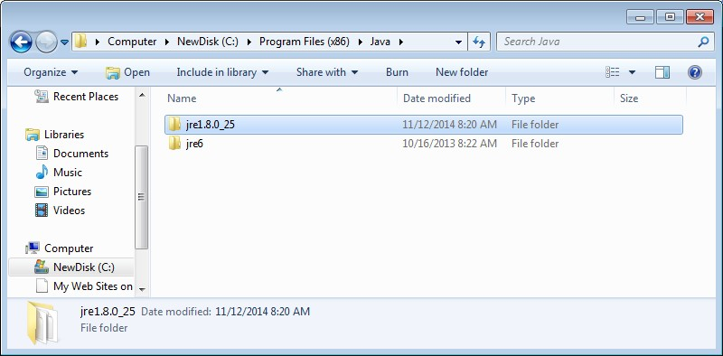

* Open the folder and follow the path to security folder

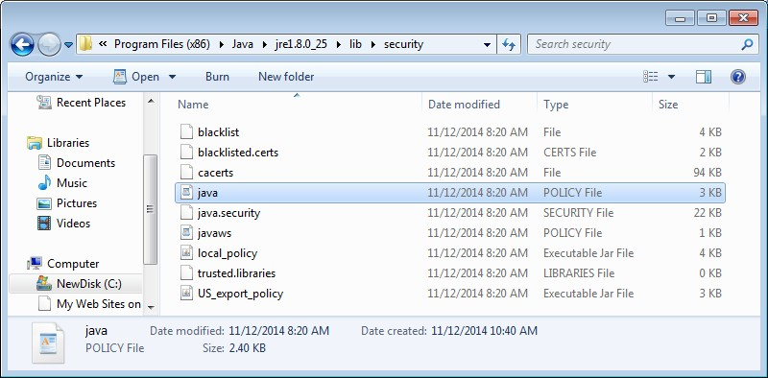

* Right click on the java file and select the Re-name option. Change the name of the java file to java_old.

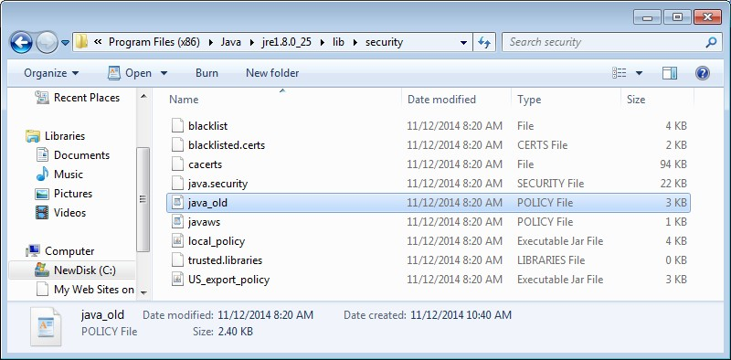

#### Placing New MKS Java security file in Java folder:

* Locate the new java policy security document (supplied by MKS) and drop it into the Java security folder.

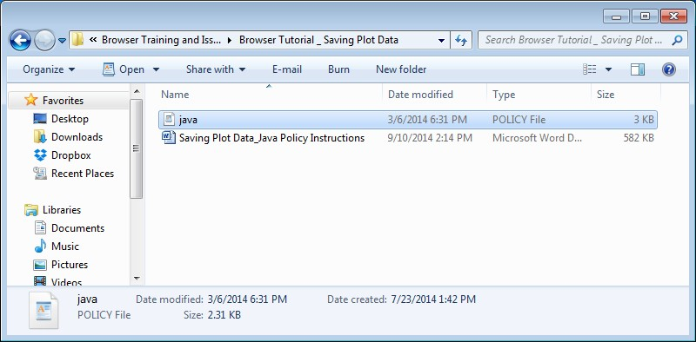

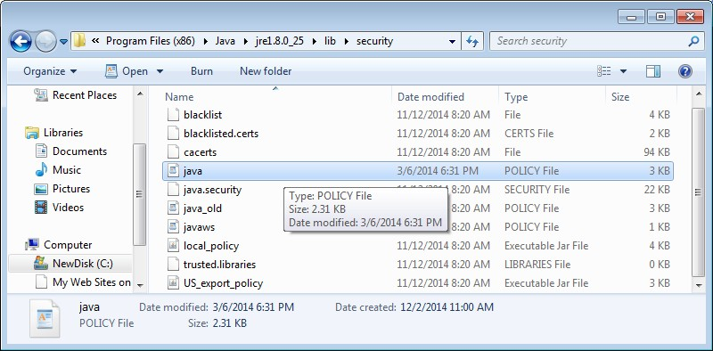

* The new java policy is in place, close the Folder.

## Creating a ToolWeb folder:

* Open the C drive on the computer. Right click and open a new folder. Rename the new folder ToolWeb. This is the folder where all data collected will be saved.

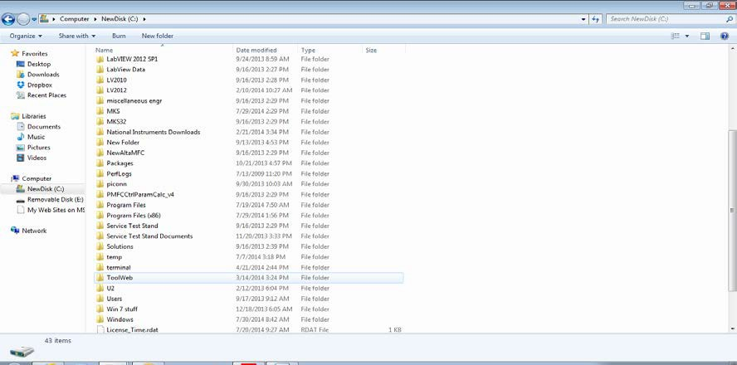

## Final Steps in configuring the plot page:

After installing the latest Java and creating the ToolWeb folder described above, there may still be a security issue when launching the plot page of the MFC Browser.

An error message pop-up may appear that indicates security settings are preventing the java applet from running.

Solution:

1. 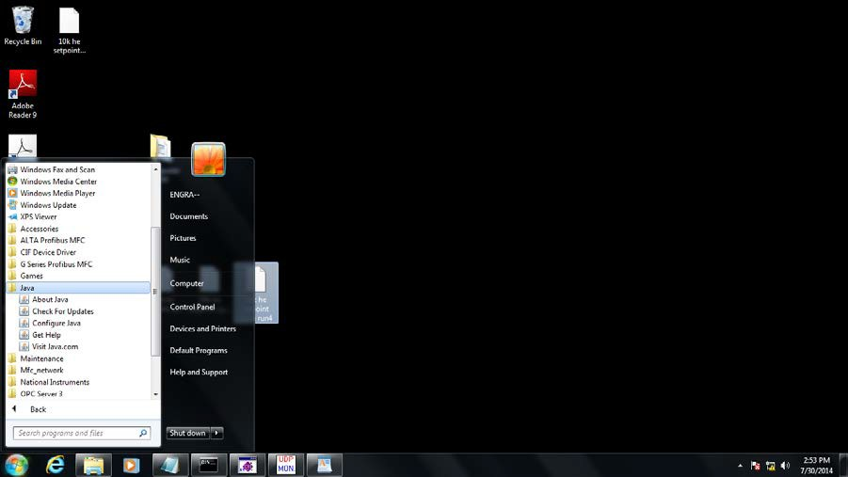Locate the Java folder in the <Programs> listing
2. Select <Configure Java>. Once open go to the <Security> tab.

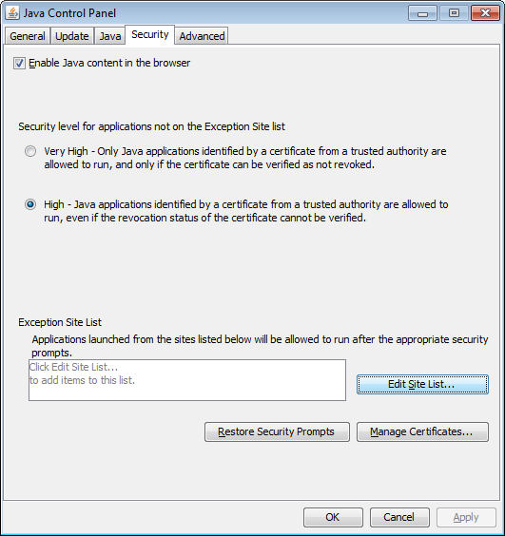

1. Click on <Edit Sites List>. Hit <Add> and type in the IP address of the MFC. Hit Enter to save it to the Exception Site List.

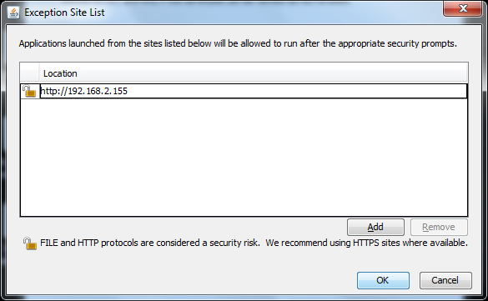

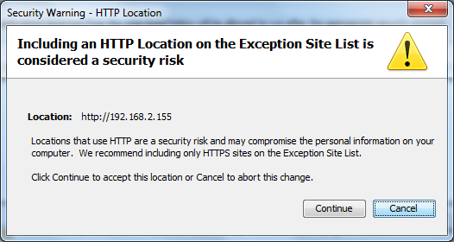

Select continue and then OK to close the <Edit List> Window.

1. Select <OK> to close the <Security>window.

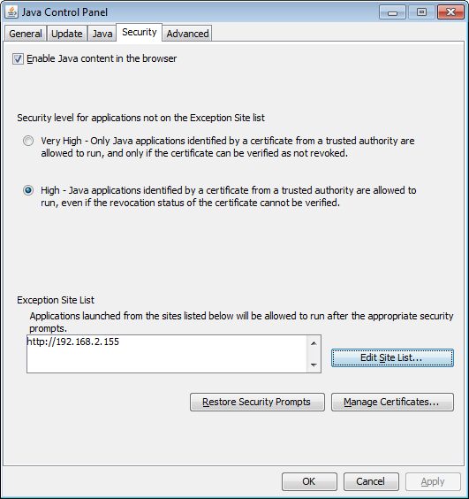

1. The IP Address is now recognized as a “Trusted” Site and the Jave applet will run when the Plot page is launched.
2. Close the Browser and re-launch to allow all the java changes to take effect.

# Appendix B – Completing the Firmware Upgrade Task

* In order to complete the process of upgrading the firmware of an MFC any new parameters or changes to existing parameters being introduced into the MFC from the upgrade must be initialized in the gas table files that exist on the MFC.
* Completing this task requires entering into the Factory Mode of the Web Browser.
* Section 4 covers how to access the Factory Mode and details of how to execute a parameter save command that will accomplish this task is provided in this Appendix.

#### Additional Steps to Completing a Firmware Revision Change:

1. Enter the Factory Browser and go to the <Device> page. Using the <Gas Settings> pull down menu, select the N2 table in Instance 32. Hit the <Set> button in order to make the gas table, in Instance 32, active.

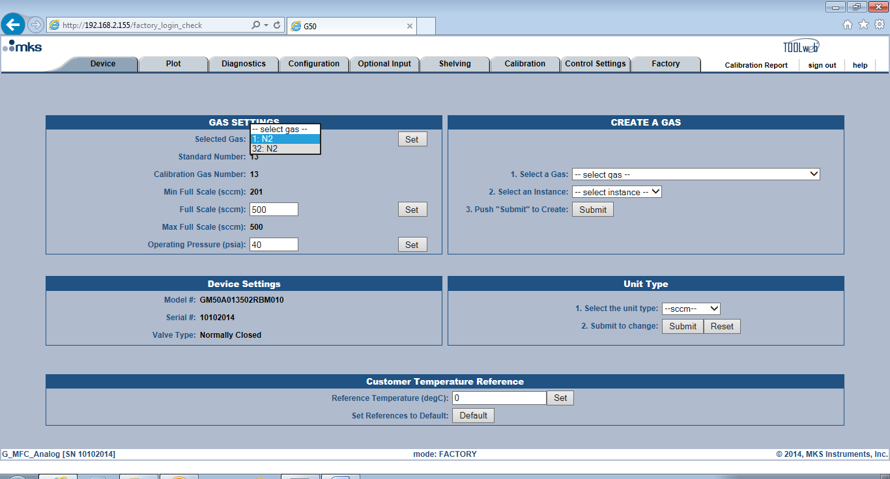

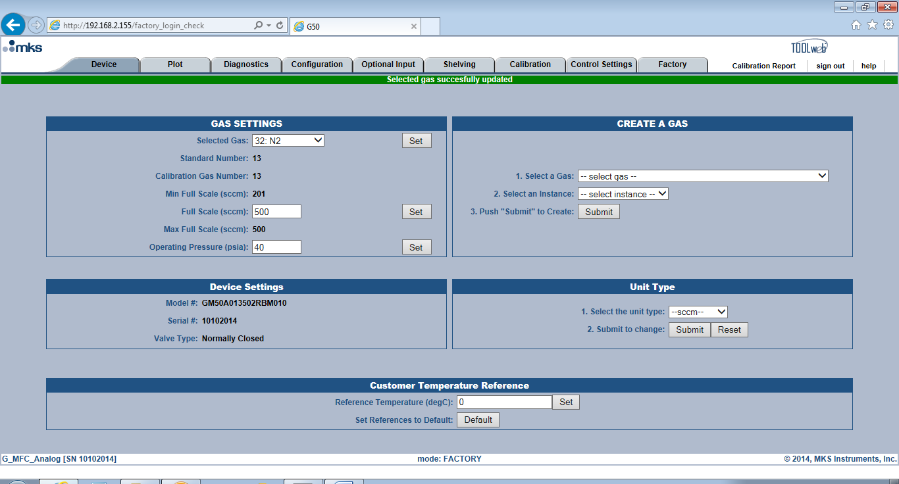

1. Click on the <Controls Setting> Tab. At the bottom of the page on the right hand side hit the

<Submit> button. This executes a flash file save and any new variables that have been included in this firmware will be properly installed in the flash memory of the Manufacturing gas table in Instance 32.

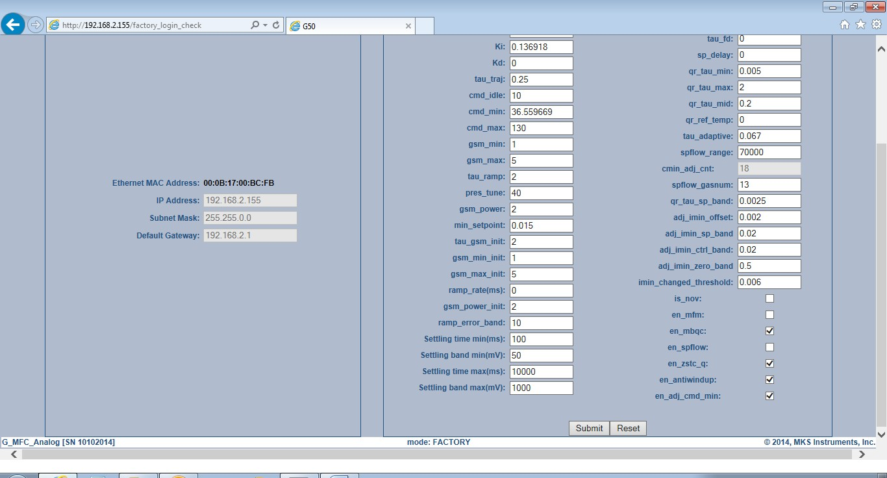

1. Return to the <Device> Tab. Using <Create a Gas>, re-create the nameplate gas table in Instance 1 in order for all the updates to be completed for this nameplate gas table. Select the gas and the instance and hit <Submit>.

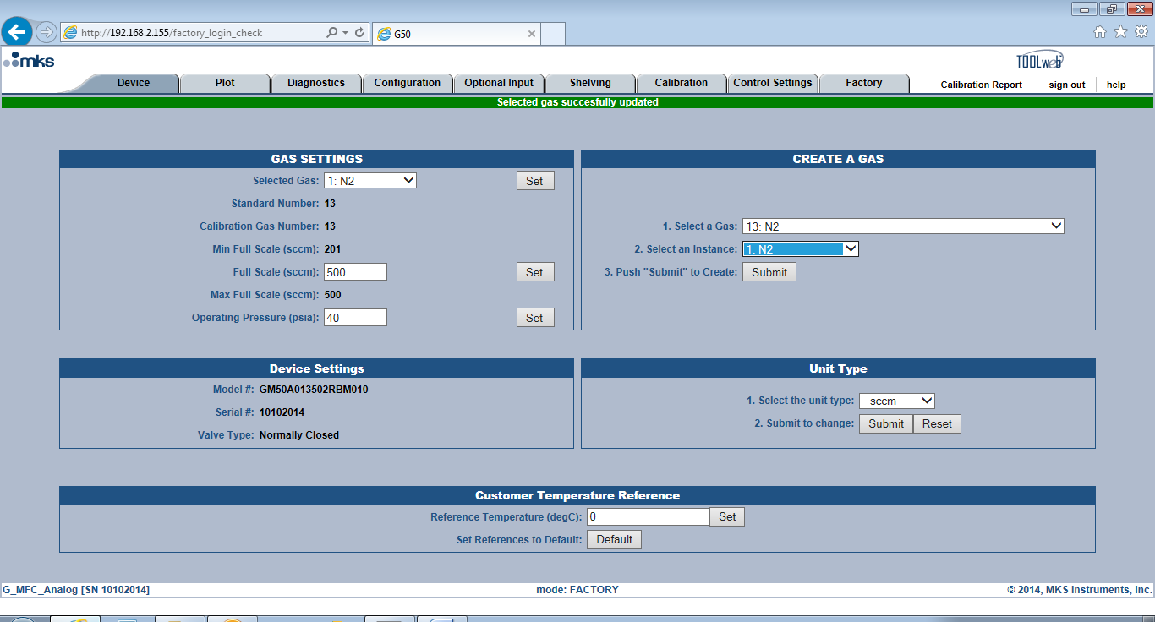

1. A popup message will ask if you want to over write the gas table in Instance 1. Click <OK> to continue the process of re-creating the gas table in Instance 1.

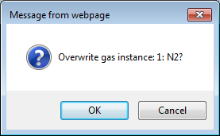

1. Once the nameplate gas in Instance 1 has been re-created, updating the MFC with new firmware is complete.

# Appendix C – Re-setting IP Address to Factory Default 192.168.2.155

* All G series MFC exit the factory with the same default IP Address - 192.168.2.155
* IP Addresses can be changed from the <Configuration> tab and if not properly noted by the user could result in not being able to establish Ethernet communication at some future date.
* If there is a communication problem when trying to open the Web Browser, one potential cause for the inability to establish Ethernet communication could be that the IP Address has been changed from it factory default.
* The IP Address maybe reset to its original factory default using the following steps.